

School of Public Administration  
Bachelor of Science in Computing

**COMP491 Final Year Project  
Final Report**Academic Year 2018/19

|  |  |
| --- | --- |
| Pattern Recognition using Machine Learning | |
|  |  |
| Project number: | 20 |
| Student ID: | P-15-0792-1 |
| Student Name: | Zhiming Lin, Tony |
|  |  |
| Supervisor: | Dr. Yue Liu, June |
| Assessor: | Dr. Xu Yang |
|  |  |
| Submission Date: | 12/4/2019 |

Declaration of Originality

I, Zhiming Lin, declare that this report and the work reported herein was composed by and originated entirely from me. This report has not been submitted in any form for another degree or diploma at any university or other institute of tertiary education. Information derived from the published and unpublished work of others has been acknowledged in the text and a list of references is given in the bibliography.



12/4/2019

Abstract

Nowadays, traffic congestion is a serious problem all around the world. All kinds of traffic control techniques are applied to relieve this issue. This project retrains three different versions of You Only Look Once (YOLO) [1] models (the modern real-time object detection model using neural network), YOLOv2 [2] model, tiny YOLOv2 model and YOLOv3 [3] model. These three models are also applied on the real-time traffic images from the Transport Bureau of the Macao S.A.R. (DSAT) [4] website to detect vehicles on the roads. Their performances are compared in detail under the local circumstance with the consideration of the limitations of DSAT surveillance materials. Meanwhile, the web application which is especially built for real-time object detection models is also implemented. Real-time traffic images and prediction results of three models will be displayed in the website.

The three different YOLO models are retrained to gain better performance on self-made DSAT datasets which consist of 3901 object-labeled traffic images. The tiny YOLOv2 model increases its mean average precision (mAP) more than 50% after retraining. As for the most accurate model among the three models, the YOLOv2 model can achieve 61.45% mAP.

This project is especially designed to analyze traffic condition in Macao. The well-retrained models have significant improvement accuracy compared to original object detection models. The YOLO models which have fast processing speed ensure that the prediction can be finished in a very short time. The web application allows commuters to view the real-time traffic images and have better ideas about current traffic congestion level.

Acknowledgement

I would first like to say a special thank you to my supervisor, Dr. June. I had a really challengeable time during my first semester of 4th year study. I was struggling at preparing all kinds of tests and applying for my graduate schools by myself. At the same time, I have no idea how to start this final year project. Thankfully, Dr. June helps me to tackle all the problems I have encountered. She always shows her kindness and considerateness and even encourages me during my hardest time. This project cannot be done without her.

Secondly, I intend to appreciate my friends who give me suggestions. Thank you, Joe Wong, for giving me the idea of traffic pattern recognition on the DSAT website. I really appreciate Julight Zhong for providing me the useful technical suggestions. I also need to say thank you to my friends who are always with me.

Finally, I must express my gratitude to my family. They always give me undoubted and strong support and encouragement. This project would be impossible to finish without them.

Table of Contents

1 Introduction 10

1.1 Objectives 10

1.2 Risk Assessment 11

1.3 Summary 12

2 Background and Related Work 14

2.1 Python [5] 14

2.2 TensorFlow [6] 14

2.3 Keras [7] 14

2.4 OpenCV [8] 14

2.5 Flask [9] 15

2.6 Object Detection 15

2.6.1 Histogram of Oriented Gradients with Support Vector Machine [10] 15

2.6.2 Convolutional Neural Network [11] 15

2.6.3 YOLO 18

2.7 Related Work 18

2.7.1 Traffic Analysis Method Proposed by A. Atvar, Y. Artan and Ş. Öztürk [12] 18

2.7.2 Traffic Congestion Analysis Proposed by J. Wan, Y. Yuan and Q. Wang [14] 19

3 Design Approach 20

3.1 Datasets 20

3.2 Models 21

3.2.1 YOLOv1 21

3.2.2 YOLOv2 24

3.2.3 YOLOv3 25

3.2.4 Average Precision 26

3.3 Web Application 27

4 Implementation 29

4.1 Datasets 29

4.1.1 Crawling images from the DSAT website 29

4.1.2 Cleaning downloaded images 31

4.1.3 Labeling images 32

4.1.4 Creating datasets 34

4.2 Models 36

4.2.1 Tiny YOLOv2 model 37

4.2.2 YOLOv2 39

4.2.3 YOLOv3 41

4.3 Web application 44

5 Results and Discussion 51

5.1 Testing environment 51

5.2 Comparison before and after retraining 52

5.2.1 Tiny YOLOv2 52

5.2.2 YOLOv2 54

5.2.3 YOLOv3 56

5.3 Comparison between three models 59

5.3.1 Before training 59

5.3.2 After retraining 61

5.4 Web application 63

6 Conclusion and Further Work 64

6.1 Conclusion 64

6.2 Further work 64

6.2.1 Datasets 64

6.2.2 Models 64

6.2.3 Web application 65

References 66

Appendix A. Project Management 68

Appendix B. Reflection 69

Table of Figures

Figure 1: Probability impact matrix before proposed solution 15

Figure 2: A simple example of convolutional neural network……………………………….17

Figure 3: convolutional layer………………………………………………………………...18

Figure 4: fully connection layer……………………………………………………………..18

Figure 5: Maxpooling layer…………………………………………………………………..19

Figure 6: Dropout layer………………………………………………………………………19

Figure 7: Procedure of determining congestion level………………………………………..21

Figure 8: traffic imag from DSAT website…………………………………………………..23

Figure 9: traffic image from [18]…………………………………………………………….23

Figure 10: The architecture of YOLOv1……………………………………………………..24

Figure 11: The architecture of YOLOv2……………………………………………………..27

Figure 12: The architecture of YOLOv3……………………………………………………..28

Figure 13: Sequence diagram of web application……………………………………………30

Figure 14: traffic camera from the Tunel do Monte da Guia (the direction of Rodrigo)…….31

Figure 15: Crawling codes…………………………………………………………………...32

Figure 16: more than 60,000 traffic images………………………………………………….32

Figure 17: Traffic image with no vehicles…………………………………………………...33

Figure 18: Traffic image with bad lighting condition……………………………..................33

Figure 19: predefined_classes.txt…………………………………………………………….34

Figure 20: Label the vehicles………………………………………………………………...35

Figure 21: The annotation files………………………………………………………………35

Figure 22: XML format………………………………………………………………………35

Figure 23: Codes for creating three models………………………………………………….36

Figure 24: Get images for validation…………………………………………………………37

Figure 25: Codes of XML to TXT…………………………………………………………...38

Figure 26: Codes of JSON to TXT…………………………………………………………...39

Figure 27: yolo-voc-4c.cfg…………………………………………………………………...40

Figure 28: yolo-voc-4c.cfg…………………………………………………..……………….42

Figure 29: yolo_video_file.py………………………………………………………………..43

Figure 30: classes.txt…………………………………………………………………………44

Figure 31: Codes for training only on last 3 layers…………………………………………..44

Figure 32: train.py……………………………………………………………………………44

Figure 33: yolo.py……………………………………………………………………………45

Figure 34: Macao……………………………………………………………………………..47

Figure 35: Ponte……………………………………………………………………………...47

Figure 36: Taipa & Coloane………………………………………………………………….47

Figure 37: Codes for obtaining real-time traffic images……………………………………..48

Figure 38: codes for checking………………………………………………………………..48

Figure 39: codes for encoding………………………………………………………………..48

Figure 40: Codes for error checking………………………………………………………….49

Figure 41: setInterval function……………………………………………………………….49

Figure 42: Codes for cleaning interval……………………………………………………….49

Figure 43: Parameters of two YOLOv2 models……………………………………………...50

Figure 44: Load two YOLOv2 models……………………………………………………….50

Figure 45: Predict vehicles using twoYOLOv2 models……………………………………...50

Figure 46: yolo_image.py…………………………………………………………………….51

Figure 47: Load YOLOv3 model…………………………………………………………….51

Figure 48: predict vehicles using YOLOv3 model…………………………………………..51

Figure 49: countNum function……………………………………………………………….52

Figure 50: Bar chart of tiny YOLOv2 model………………………………………………...54

Figure 51: Bar chart of retrained YOLOv2 model…………………………………………...55

Figure 52: Training loss of tiny YOLOv2 model…………………………………………….55

Figure 53: Validation loss of tiny YOLOv2 model…………………………………………..55

Figure 54: Bar chart of YOLOv2 model……………………………………………………..56

Figure 55: Training loss of YOLOv2 model…………………………………………………57

Figure 56: Validation loss of YOLOv2 model……………………………………………….57

Figure 57: Bar chart of retrained YOLOv2 model…………………………………………...57

Figure 58: Bar chart of YOLOv3 model……………………………………………………..58

Figure 59: Training loss of YOLOv3 model…………………………………………………59

Figure 60: Validation loss of YOLOv3 model……………………………………………….59

Figure 61: Bar chart of retrained YOLOv3 model…………………………………………...60

Figure 62: Three original YOLO models…………………………………………………….61

Figure 63: Tiny YOLOv2 (light)……………………………………………………………..61

Figure 64: YOLOv2 (light)…………………………………………………………………..61

Figure 65: YOLOv3 (light)…………………………………………………………………..61

Figure 66: Tiny YOLOv2 (heavy)……………………………………………………………62

Figure 67: YOLOv2 (heavy)…………………………………………………………………62

Figure 68: YOLOv3 (heavy)…………………………………………………………………62

Figure 69: Three retrained YOLO models…………………………………………………...63

Figure 70: Tiny YOLOv2 (light)……………………………………………………………..63

Figure 71: YOLOv2 (light)…………………………………………………………………..63

Figure 72: YOLOv3 (light)…………………………………………………………………..63

Figure 73: Tiny YOLOv2 (heavy)……………………………………………………………64

Figure 74: YOLOv2 (heavy)…………………………………………………………………64

Figure 75: YOLOv3 (heavy)…………………………………………………………………64

Figure 76: web application…………………………………………………………………...65

Figure 77: Gantt chart 1………………………………………………………………………70

Figure 78: Gantt chart 2………………………………………………………………………70

List of Tables

Table 1: Table of prioritized risk 8

Table 2: Summary of three retrained YOLO models…………………………………….......53

# Introduction

Nowadays, the traffic congestion is one of the major problems in metropolitan cities, such as Macao. Many people complain about the time they have to spend on their commuting especially during the rush hours. Thankfully, the DSAT website provides real-time traffic images from different roads of Macao. It allows people to have closer look at current traffic flow on the roads. Therefore, they can use alternative routes and avoid traffic jams on major roads accordingly. However, the website does not provide the exact number of vehicles on the roads or show the congestion level of traffic condition in real time. Commuters have to count the number of vehicles to analyze the current traffic congestion level subjectively, which is not convenient and accurate at all. It will be better that the real-time object detection system is implemented to detect vehicles and count the volume of vehicles on the roads.

It is quite well known that object detection has been discussed over a decade. There are many object detection algorithms and ideas, whose improvements on prediction accuracy are always the hot spot of the field. However, these algorithms have not been well designed and discussed for detecting vehicles under Macao’s traffic conditions. In terms of the traffic conditions in Macao, it has its own features:

1. Roads in Macao are quite narrow.

2. The traffic images from the DSAT website are not clear but blurred.

Finding the object detection algorithm which can be applied in Macao with better performance is the highlight of this project. Also, the improved versions of object detection algorithms which build on the original ones will be explored. The prediction results and real-time traffic images are visualized on the web application so that it is convenient for the commuters to view.

## Objectives

The goal of this project is to implement an object detection algorithm for detecting the vehicles on the traffic images from the DSAT website. It would help people to find out the congestion level on the roads. Nowadays, there are many image recognition and machine learning algorithms to detect objects. However, not all the algorithms are suitable for recognizing vehicles on images from traffic cameras. Therefore, literatures review on object detection using machine learning especially for traffic images should be done. It is also necessary to do some analysis based on the detection results.

The objectives of this project are:

* Identify the problem of image recognition: traffic pattern recognition.
* Do literatures review on image recognition and machine learning algorithms.
* Implement a machine-learning algorithm to recognize the traffic condition.
* Test the algorithm using real-time traffic image crawled from DSAT website and analyze the traffic results.
* Compose a final project report.

## Risk Assessment

Risk one: Datasets are lost.

Solution: The datasets are indispensable to the whole project. It is important to have backups of datasets. Therefore, at least one copy of datasets should be available in such as USB (Universal Serial Bus) flash drive or cloud drive. Once the original datasets are lost, the backup datasets can be used immediately.

Risk two: Traffic images from DSAT website are blurred.

Solution: The object detection algorithm needs to extract information from the training images and learn through them to detect different kinds of vehicles. Thus, the quality of traffic images is one of the significant keys to the project. In order to get traffic images as clear as possible and prevent low quality of images from affecting the performance of retraining models, images with poor lighting conditions from the DSAT website should not be used. Instead, the traffic images which have good lighting conditions should be used for retraining and testing object detection algorithm.

Risk three: The web server cannot run the object detection models to predict vehicles.

Solution: It is possible that the web application is not able to run object detection models to detect vehicles. Therefore, in order to minimize the risk as low as possible, the same programming language should be used in both implementing the object detection models and developing web application.

Table 1: Table of prioritized risk

|  |  |
| --- | --- |
| Priority | Risk Identifier and Description |
| 1 | Risk 1: Datasets are lost. |
| 2 | Risk 2: Traffic images from DSAT website are blurred. |
| 3 | Risk 3: The web server cannot run the object detection models to predict vehicles. |

|  |  |  |  |  |
| --- | --- | --- | --- | --- |
| **Probability** | High |  |  | Risk 2 |
| Medium |  | Risk 1 | Risk 3 |
| Low |  |  |  |
|  |  | Low | Medium | High |
|  |  | **Impact** | | |

Figure 1: Probability impact matrix before proposed solution

## Summary

Aim at using object detection algorithms to detect vehicles on traffic images from the DSAT website and further discussing and visualizing about the detection results, this report is organized as follows: Chapter 2 introduces the background and related work. Chapter 3 presents the design approach involved. Chapter 4 shows the implementation of object detection. In chapter 5, the results and discussion of object detection in traffic images are provided. At last, chapter 6 concludes the work and discusses the future work.

# Background and Related Work

## Python [5]

Python is a powerful object-oriented programming language which is available in Windows, Linux and Mac OS. The syntax of Python is much easier to understand compared to other programming languages. This makes Python friendly to learn and is becoming more and more popular in the world. There are thousands of great third-party modules for Python. This project uses the Python as the main development programming language.

## TensorFlow [6]

TensorFlow is the tool which is used in this project. It provides powerful tools and functions that can ease the development. TensorFlow is developed by Google. TensorFlow is a perfect tool for building deep learning neural network. It can apply different techniques of deep learning. Also, TensorFlow is able to be deployed at different operating systems like Windows, Linux and Mac OS. This powerful and handy software can speed up the development time and improve efficiency.

## Keras [7]

Keras is one of the Python deep learning libraries built on TensorFlow. Because of its high-level neural networks API, Keras can help to reduce the work of building TensorFlow applications. Moreover, it supports Windows, Mac OS and Linux operating system which can ease the difficulties of development in different platforms. The detailed documentation from Keras official website could speed up the developments.

## OpenCV [8]

OpenCV is the Open Source Computer Vision Library. The library is cross-platform-compatible and it can also run on Windows, Linux and Mac OS operating systems. The images and videos are computed and processed efficiently by this computer vision library. OpenCV supports Python interface which is also the main development programming language in this project, therefore, the project uses this library to process the images.

## Flask [9]

Flask is a micro web framework which is written in Python. It does not require any specific tools or libraries. Because it is a light web framework and easy to use, this project uses Flask to build a web server. In addition, object detection models can be deployed to the web server where people can get the prediction results directly.

## Object Detection

### Histogram of Oriented Gradients with Support Vector Machine [10]

Before the convolutional neural network [11] becomes the state-of-art machine learning models, HOG+SVM (histogram of orients gradients with support vector machine) is quite popular and robust object detection algorithm. During training, the model would extract the oriented gradients from training images and create histograms based on the extracted gradients, then it would use these histograms to train support vector machine to detect objects.

### Convolutional Neural Network [11]

Recently, the concept of convolutional neural network has been improved the accuracy of object detection increasingly. The deep learning models allow people to detect more even complicated objects. One convolutional neural network can contain several or hundreds of layers and functions to better extract information and learn attributes of objects. According to different purposes of layers, there are convolutional layer, fully connection layer, pooling layer and dropout layer, etc. The example can be seen in Figure 2.

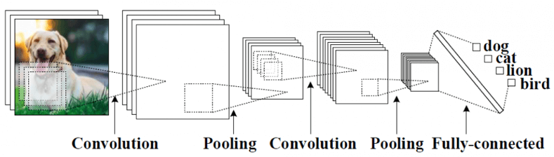

**Figure 2 A simple example of convolutional neural network**

#### Convolutional layer

Convolutional layer (Figure 3) can be the important parts in the convolutional neural network. The network mainly learns features through convolutional layer. In this layer, the activation function will be used to do the computation. There are many activation function, such as Sigmoid, ReLU, Linear, etc.

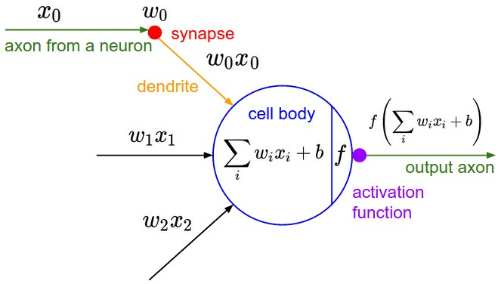

**Figure 3 convolutional layer**

#### Fully connection layer

the fully connection layer (Figure 4) can be seen as the convolutional layer. But this layer is mainly at the end of the network. This layer will perform classification based on the information and extracted features from the previous layers.

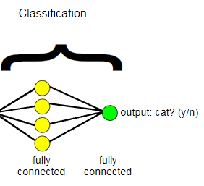

**Figure 4 fully connection layer**

#### Pooling layer

The pooling layer (Figure 5) will reduce the size of data and maintain the important information at the same time. There are many different kinds of pooling techniques in the pooling layer. Maxpooling is the most common way to perform pooling. It will take the maximum value in given range.

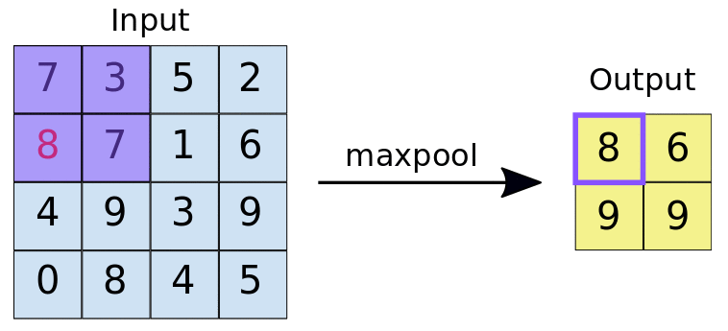

**Figure 5 Maxpooling layer**

#### Dropout layer

The dropout layer (Figure 6) will increase the stability of the convolutional neural network. It prevents overfitting problem by deactivating some neurons randomly when training the model. If the model has overfitting problem, which means that this model performs too well only on the training datasets rather than other datasets.

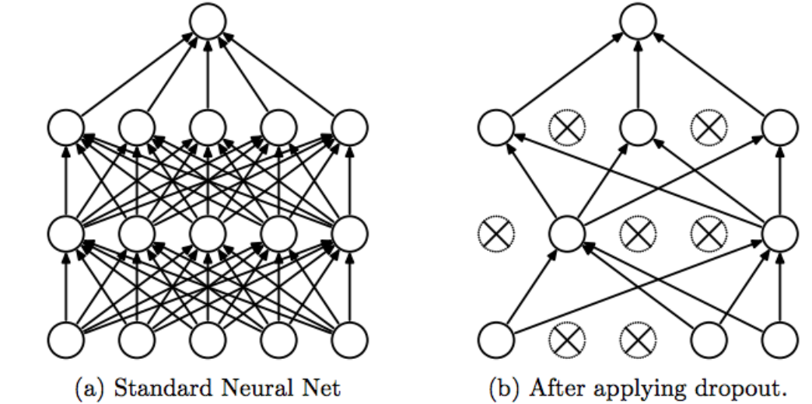

**Figure 6 Dropout layer**

### YOLO

You Only Look Once (YOLO) is the state-of-art real-time object detection system. It uses the concept of convolutional neural network with different layers which have different functionalities. Unlike other detection systems, the YOLO only uses a single neural network to detect objects on the full image. This architecture makes the process of YOLO detecting objects run extremely fast and return prediction results instantly. There are three main versions of YOLO, which are YOLOv1, YOLOv2 and the latest version YOLOv3. There are also less complicated versions of YOLO that have much fewer layers in the network.

## Related Work

Nowadays, many researchers have been investigating and providing solutions for solving the traffic congestion problems in different places. Different advanced and smart algorithms have been implemented to analyze the traffic flow especially on the images from traffic cameras. The related work about traffic analysis is stated.

### Traffic Analysis Method Proposed by A. Atvar, Y. Artan and Ş. Öztürk [12]

As this paper stated, the traffic camera is used to detect traffic intensity. A specific region is selected manually from the images of traffic cameras for detection. In this paper, Leunger-Malik (LM) filter [13] is used to extract attributes from the images. After that, the random forest algorithm which is one of the machine learning algorithms is used to determine the road occupancy. However, this may not apply to Macao situation perfectly because the roads in Macao are quite narrow and also the congestion level is better detected by machine automatically without other user inputs. Also, there already exists the modern machine learning algorithms which can achieve better detection accuracy than this one.

### Traffic Congestion Analysis Proposed by J. Wan, Y. Yuan and Q. Wang [14]

In this paper, a new system is proposed to detect traffic congestion level. The traffic images from traffic cameras are used to perform Inverse Perspective Mapping (IPM) into desired transformed image. After that, the transformed image is split into several regions to operate feature extraction. These features are merged together into final features which will be used to determine the congestion level. The procedure can be seen in Figure 7.

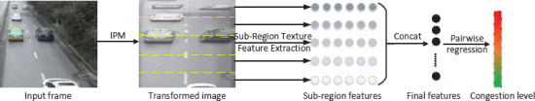

**Figure 7 Procedure of determining congestion level**

Also, two deep learning methods are used as comparisons. The first deep network is a minor variation of AlexNet [15]; the second network is CNN-LSTM [16]. However, the results are not satisfied due to weak label of the vehicles’ positions and not well-tuned neural networks. Thus, the well-designed machine learning algorithms should be used to determine the congestion level.

# Design Approach

The real-time object detection requires not only high prediction precision but also fast processing speed. The YOLO is the perfect object detection model for this project.

## Datasets

The quality of dataset is crucial for training a robust object detection model with high prediction accuracy. If the dataset contains images which have low resolutions or bad lighting conditions, it would be difficult and inefficient for object detection model to extract and learn the attributes from the images.

In order to train the object detection model that can detect objects and locate them using bounding boxes, datasets consist a large amount of labeled traffic images are required. Google Dataset Search [17] provides a variety of datasets which may include suitable datasets for this project.

However, there is no such dataset which include a large number of traffic images with annotation after searching.

Most of the traffic images datasets have no annotations. For example, there is a dataset of unlabeled traffic images provided by the city of Calgary, Canada [18]. But there are significant differences in the traffic images provided from the DSAT website and the traffic images from this dataset. Their differences are summarized as below.

Firstly, the quality of images provided by [18] has 840 × 630 resolutions compared to 352 × 288 resolutions from the DSAT website. Also, when both traffic images have bad lighting conditions during night time, the traffic images from [18] are much clearer than that from the DSAT website (Figure 8 and Figure 9). Finally, the traffic images from Calgary are updated every minute, while the traffic images from the DSAT website are updated every 5 seconds. Finally, the roads in Calgary are much wider than that in Macao.

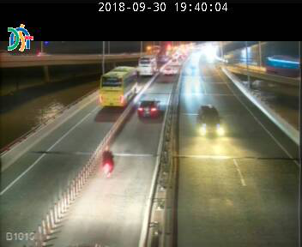 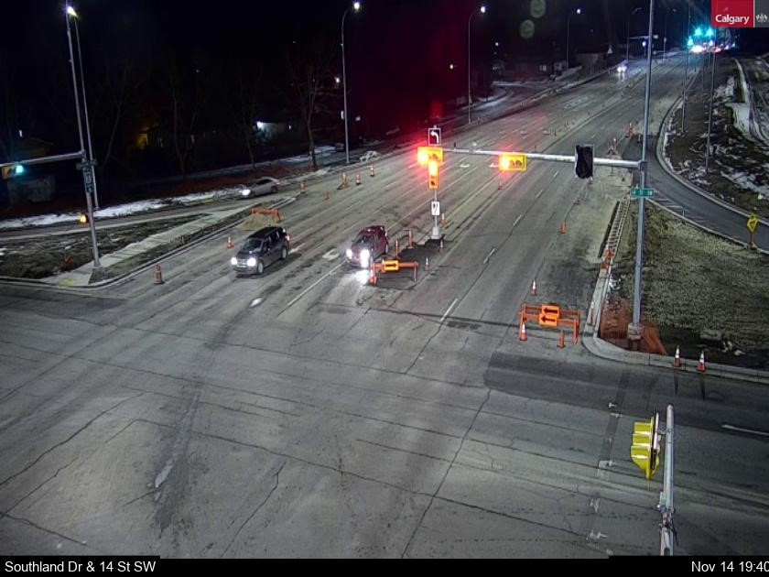

**Figure 8 traffic imag from DSAT website Figure 9 traffic image from [18]**

Because the traffic images provided by existing datasets have no annotations and are quite different from the traffic images provided by the DSAT website, the web crawling is applied to crawl images from the DSAT website. The explicit implementation of web crawling and setting up datasets will be discussed in the chapter 4.

## Models

Because of the requirements of high prediction accuracy and fast prediction speed, the modern real-time object detection system, YOLO, is used to detect vehicles in this project. The key points of YOLOv1 model, (tiny) YOLOv2 models and YOLOv3 model will be discussed.

### YOLOv1

The very first version of YOLO, YOLOv1 was introduced in June 2015. According to this paper, the best YOLOv1 model can predict objects on the images at 45 frames per second. In addition, on both the People-Art Dataset and the Picasso Dataset, this model can outperform other models including Region CNN (R-CNN) [19] and Deformable Parts Models (DPM) [20]. The following are some important points about YOLOv1:

1. YOLOv1 does not use sliding window search [10] and region proposal-based techniques [19], it predicts objects and location of objects through viewing the entire image.
2. YOLOv1 separates the image into *S × S* grid cell. Each grid cell predicts *B* bounding boxes and the confidence for these boxes.
3. In terms of predicting classes of objects, YOLOv1 predicts one group of class probabilities for every grid cell. If the total number of classes is C, YOLOv1 will return C conditional class probabilities for every grid cell.
4. In order to locate the bounding boxes, YOLOv1 contains 5 predictions. The coordinate (*x, y*) stands for the central coordinate of bounding box relative to the responsible grid cell. Height & weight of bounding boxes are relative to the whole image. Lastly, the last prediction is class-specific confidence score (1) which is $P_{r}({Class}_{i})*$ $IoU_{pred}^{truth}$. The first term is the probability of a cell containing an object. The second term is the Intersection over Union (IoU) between the predicted box and the ground truth box. The IoU is calculated by the area of overlap over the area of union. Therefore, the final prediction is an *S × S × (B * 5 + C)* tensors.

|  |  |
| --- | --- |
| Confidence score = * * = * | (1) |

1. The YOLOv1 has totally 24 convolutional layers, 5 maxpooling layers and 2 fully connection layers. (Figure 10)

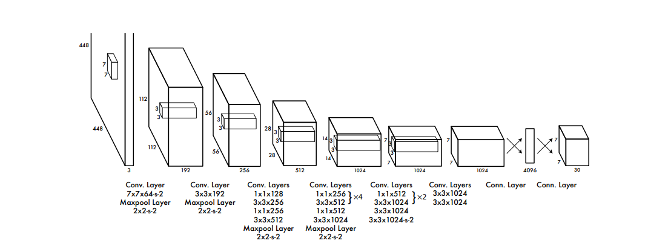

**Figure 10 The architecture of YOLOv1**

1. The input image size is 448 × 448 which can have better visual feature.
2. In terms of activation functions for the neural networks, the YOLOv1 uses linear activation function (2) for the final layer and leaky rectified linear activation (3) for the rest of layers.

|  |  |
| --- | --- |
| $$∅\left(x\right)=x$$ | (2) |

|  |  |
| --- | --- |
|  | (3) |

1. The loss function is the critical part of training a good model (4). The YOLOv1 introduces two parameters $λ_{coord}$ and $λ_{noobj}$ to maximize the precision. In order to penalize more on the coordinate predictions of bounding boxes and less when the bounding boxes don’t contain objects. The first parameter has the value 5 which is much larger than the second parameter which is 0.5. The design introduces the improvement on both accuracy and stability.

|  |  |
| --- | --- |
| loss = $λ_{coord}\sum_{i=0}^{s^{2}}{\sum_{j=0}^{B}{l_{ij}^{obj}}}[{\left(x_{i}-{\hat{x}}_{i}\right)}^{2} -{(y_{i}-{\hat{y}}_{i})}^{2}]$ $+ λ_{coord}\sum_{i=0}^{s^{2}}{\sum_{j=0}^{B}{l_{ij}^{obj}}}\left[{\left(\sqrt{w_{i}}-\sqrt{{\hat{w}}_{i}}\right)}^{2} -{\left(\sqrt{h_{i}}-\sqrt{{\hat{h}}_{i}}\right)}^{2}\right]$  + $\sum_{i=0}^{s^{2}}{\sum_{j=0}^{B}{l_{ij}^{obj}}}{(C_{i} -{\hat{C}}_{i})}^{2}$ + $λ_{noobj}\sum_{i=0}^{s^{2}}{\sum_{j=0}^{B}{l_{ij}^{noobj}}}{(C_{i} -{\hat{C}}_{i})}^{2}$ + $\sum_{i=0}^{s^{2}}{l_{ij}^{obj}}\sum_{c∈classes}{{(p_{i}\left(c\right)- {\hat{p}}_{i}(c))}^{2}}$ | (4) |

The first line is to penalize the coordinate of bounding boxes which contain objects with the highest IoU. The second line is to penalize the width and height of bounding boxes which contain objects with the highest IoU. The third line and the fourth line are to penalize the classification of objects in the highest IoU of bounding box. The last line is to penalize the confidence score in each grid cell.

1. Emerging multiple neighbor grid cells can help to localize the large objects. In addition, the YOLOv1 uses non-maximum suppression to reduce duplicated bounding boxes.

### YOLOv2

YOLOv2, the improved version of YOLOv1, was introduced in December 2016. This model can achieve 78 mAP on VOC 2007 dataset [21] at 67 frames per second. The following changes are the keys to the decent performance:

* 1. All the convolutional layers in YOLOv2 add batch normalization. This improves the overall accuracy, while removing dropout from layers without suffering overfitting problem.
  2. In order to work better in higher resolution images, the YOLOv2 is tuned at higher resolution for 10 epochs in the beginning.
  3. The YOLOv2 introduces the idea of anchor boxes. The model only needs to predict the offsets instead of coordinates directly, which makes the model learn faster and better. Also, the YOLOv2 predicts class and confidence for each anchor box.
  4. Since the YOLOv2 uses anchor boxes rather than predicting the bounding boxes directly, it uses K-means clustering to find suitable volume and size of anchor boxes on the training set.
  5. The YOLOv2 predicts 5 bounding boxes at each grid cell. Besides that, the location coordinates are constrained in the grid cell which falls between 0 and 1. The model adjusts the size of bounding boxes according to anchor boxes.
  6. YOLOv2 adds a passthrough layer which brings the higher resolution features to gain more information.
  7. Multi-scale technique is used in YOLOv2 which can improve overall model stability and robustness. The multi-scale will randomly choose a new image size every 10 batches during training.
  8. YOLOv2 model contains 19 convolutional layers, 5 maxpooling layers and 1 global average pooling (Figure 11). This project also uses the tiny version YOLOv2, which has only 9 convolutional layers.

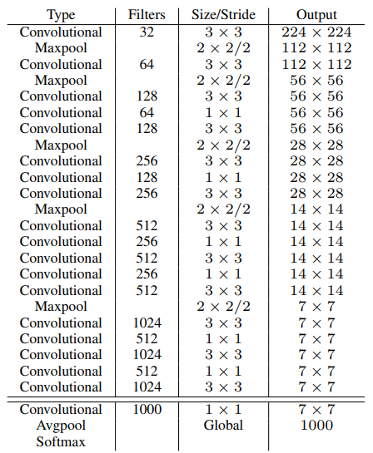

**Figure 11 The architecture of YOLOv2**

### YOLOv3

The latest version of YOLO is YOLOv3. The v3 mainly improves the prediction accuracy. The following are the changes:

* 1. The objectness score for every bounding box is predicted using logistic function.
  2. In terms of predicting classes, the softmax function in YOLOv2 model is replaced by independent logistic classifiers. The loss for class prediction is calculated by binary cross-entropy.
  3. The biggest change in YOLOv3 is that the model predicts objects in 3 different scales. Thus, there are 9 anchor boxes in total and 3 anchor boxes for each scale.
  4. YOLOv3 has 53 convolutional layers (Figure 12) which is a much larger network than both v1model and v2 model.

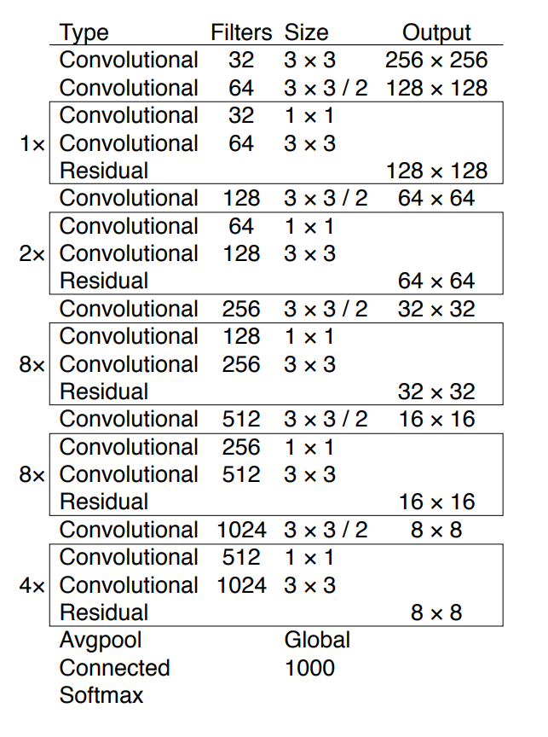

**Figure 12 The architecture of YOLOv3**

### Average Precision

The AP is used to evaluate the performance of YOLO models in this project. 4 terms should be understood firstly (they are listed below).

True Positive (TP): If the IoU is bigger than or equal to 0.5 and the model labels the objects correctly.

True Negative (TN): The object detection algorithm does not label any objects where there are no such objects.

False Positive (FP): The object detection algorithm labels the objects where there are no such objects.

False Negative (FN): The object detection algorithm does not label the objects where there are such objects.

Also, if the object is detected by multiple detections, it would count the first one as positive ones while the others are negative.

The precision (5) and recall (6) can be calculated:

|  |  |
| --- | --- |
| Precision = $\frac{TP}{TP+FP}$ | (5) |

|  |  |
| --- | --- |
| Recall = $\frac{TP}{TP+FN}$ | (6) |

the AP is calculated by finding area under the precision-recall graph. After that, the mean average precision (mAP) can be calculated by taking the mean of all the APs.

## Web Application

The web application involves three entities: users, web server and DSAT website. Since the web server obtains the real-time traffic images and there are many traffic cameras in Macao, it is not necessary to use database to store traffic images. After the user makes a request to web server, this server will return the traffic image of a certain road which the user selects. At the same time, the server will return different prediction results from three YOLO models. The image and prediction results will be updated every 5 seconds.

The sequence diagram is show as Figure 13. The implementation of the web application will also be discussed in Chapter 4.

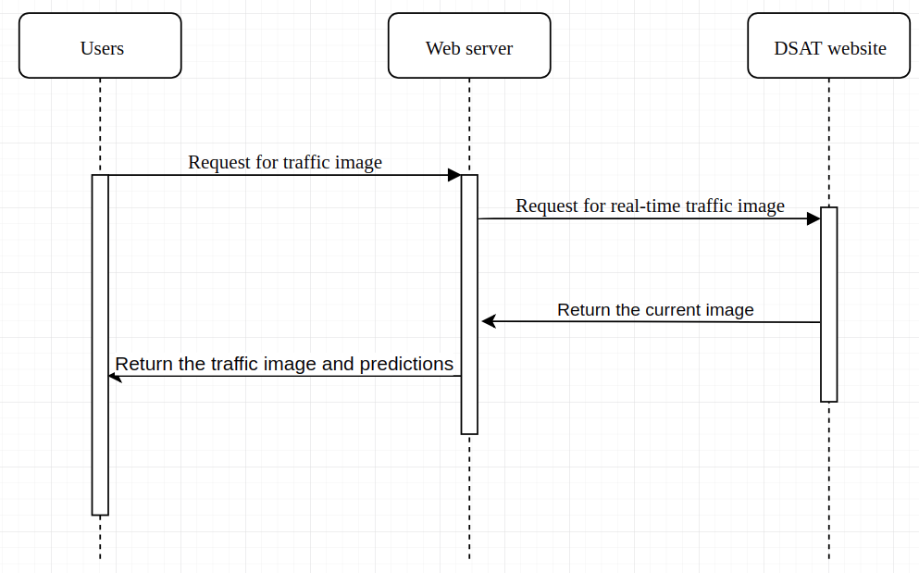

**Figure 13 Sequence diagram of web application**

# Implementation

In this chapter, the steps of setting up datasets, training YOLO models and building web application are discussed below. The Ubuntu operating system is used in this project.

## Datasets

### Crawling images from the DSAT website

First of all, the traffic images from the DSAT website should be crawled. It is important to choose a good traffic camera which have good angle and provides clear traffic images. Fortunately, the traffic camera from the Tunel do Monte da Guia (the direction of Rodrigo) can fulfill both requirements (Figure 14).

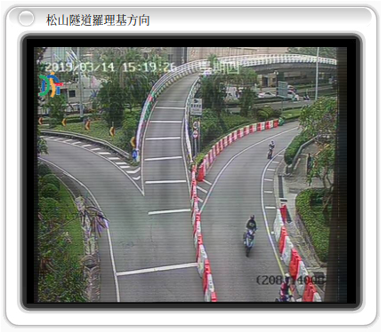

**Figure 14 traffic camera from the Tunel do Monte da Guia (the direction of Rodrigo)**

The Python3 should be installed by the command:

|  |
| --- |
| *sudo apt-get install python3* |

The web crawling codes for this place are shown in Figure 15.

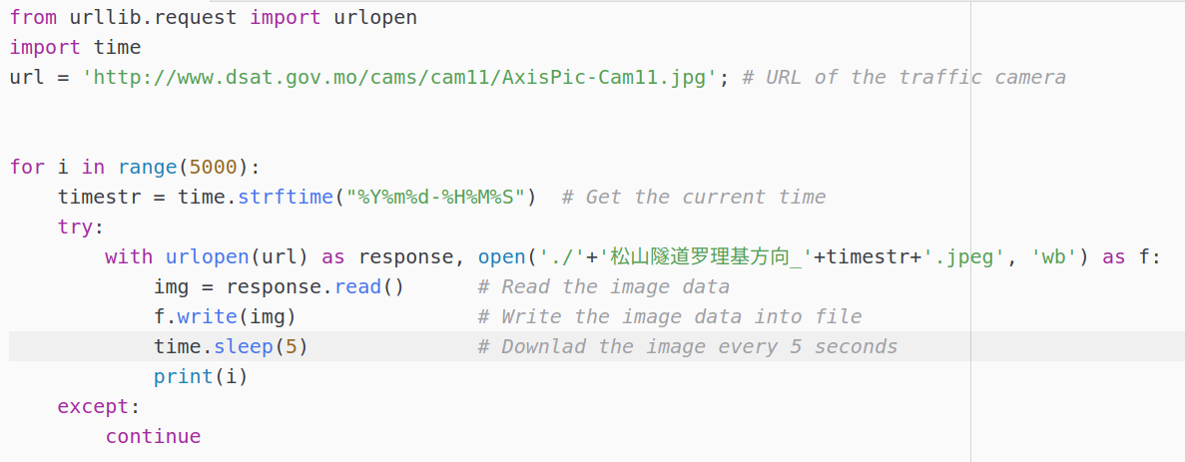

**Figure 15 Crawling codes**

The codes use the URL of certain traffic camera and then download the current traffic images from the DSAT website every 5 seconds.

Using this method, more than 60,000 traffic images have been downloaded from different locations of traffic cameras (Figure 16).

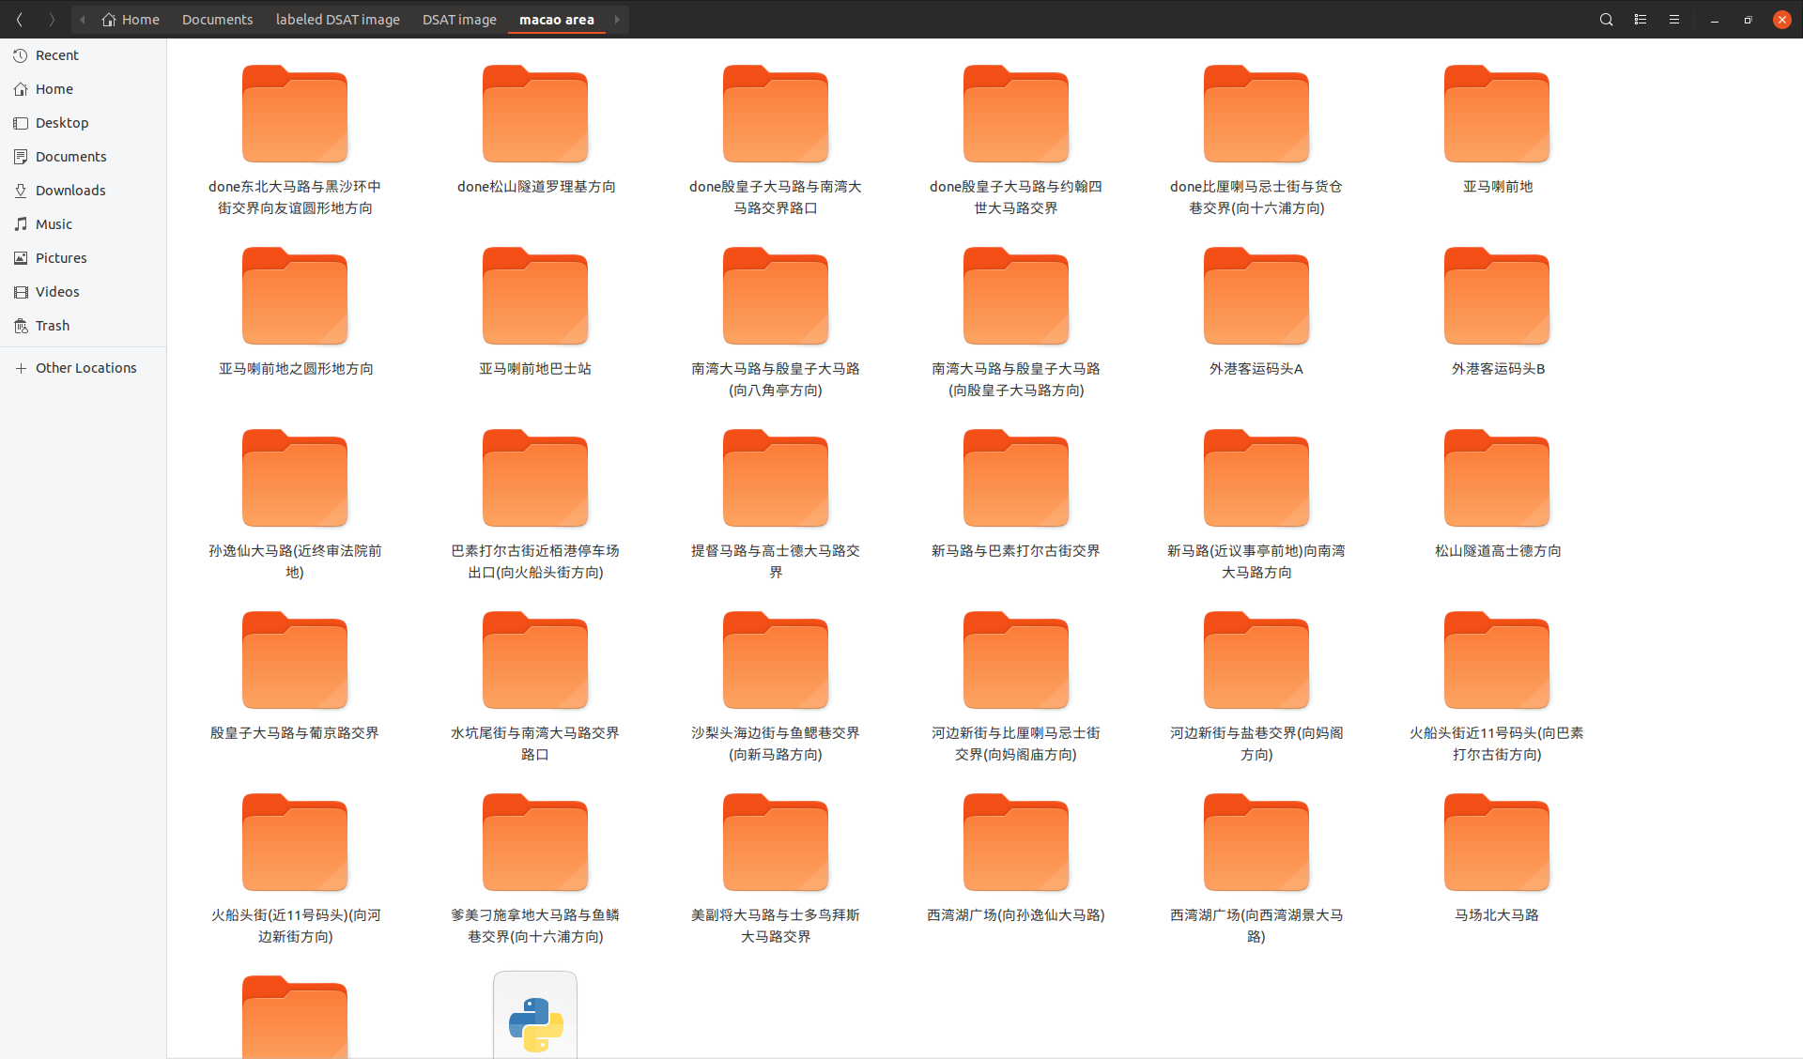

**Figure 16 more than 60,000 traffic images**

### Cleaning downloaded images

Before labeling images, there are three kinds of situations that the downloaded traffic images should not be used. Firstly, the traffic images (Figure 17) contains no vehicles.

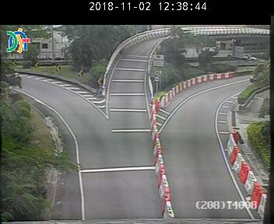

**Figure 17 Traffic image with no vehicles**

Secondly, duplicated traffic images are downloaded when the DSAT website may delay the updates of current traffic images for a short time.

Thirdly, the traffic images have bad lighting conditions (Figure 18) especially during the night.

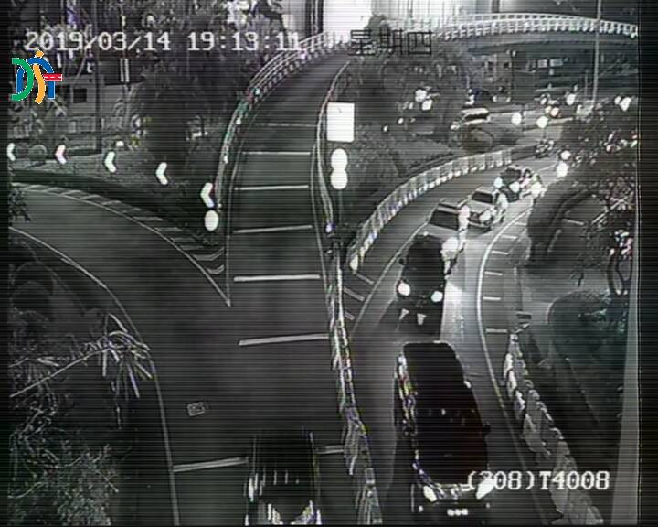

**Figure 18 Traffic image with bad lighting condition**

### Labeling images

Well labeled images provide precise ground truth for localization during training and testing models. In this project, LabelImg [22] is used to annotate images.

Firstly, after downloading and extracting the files, the LabelImg is setup by the following codes:

|  |
| --- |
| *sudo apt-get install pyqt5-dev-tools*  *sudo pip3 install –r requirements/requirements-linux-python3.txt*  *make qt5py3* |

Secondly, the classes should be defined in the *data/predefined_classes.txt.* Usually, there are four kinds of vehicles on the roads in Macao: car, motorbike, bus and truck. Therefore, the classes of objects should be defined as the figure below:

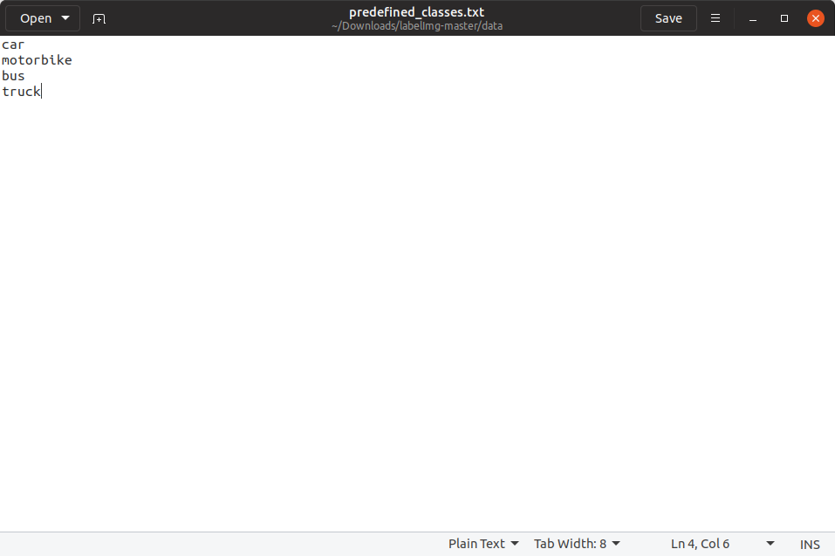

**Figure 19 predefined_classes.txt**

After running the main program, the vehicles on the traffic images are annotated by bounding boxes and labeled with the belonging classes (Figure 20).

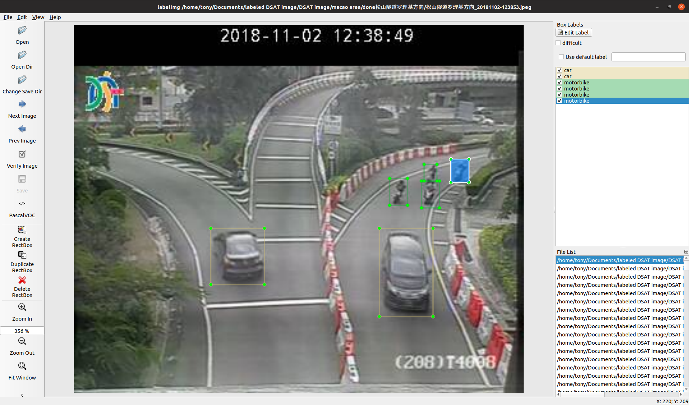

**Figure 20 Label the vehicles**

The annotations are saved in XML format (Figure 21 and Figure 22).

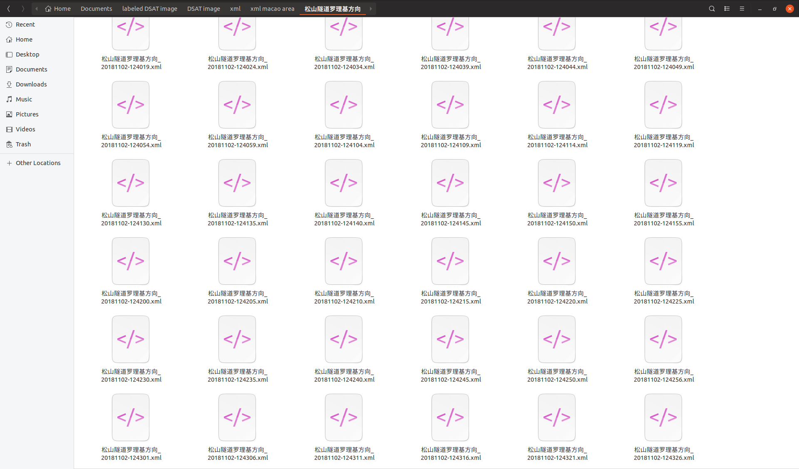 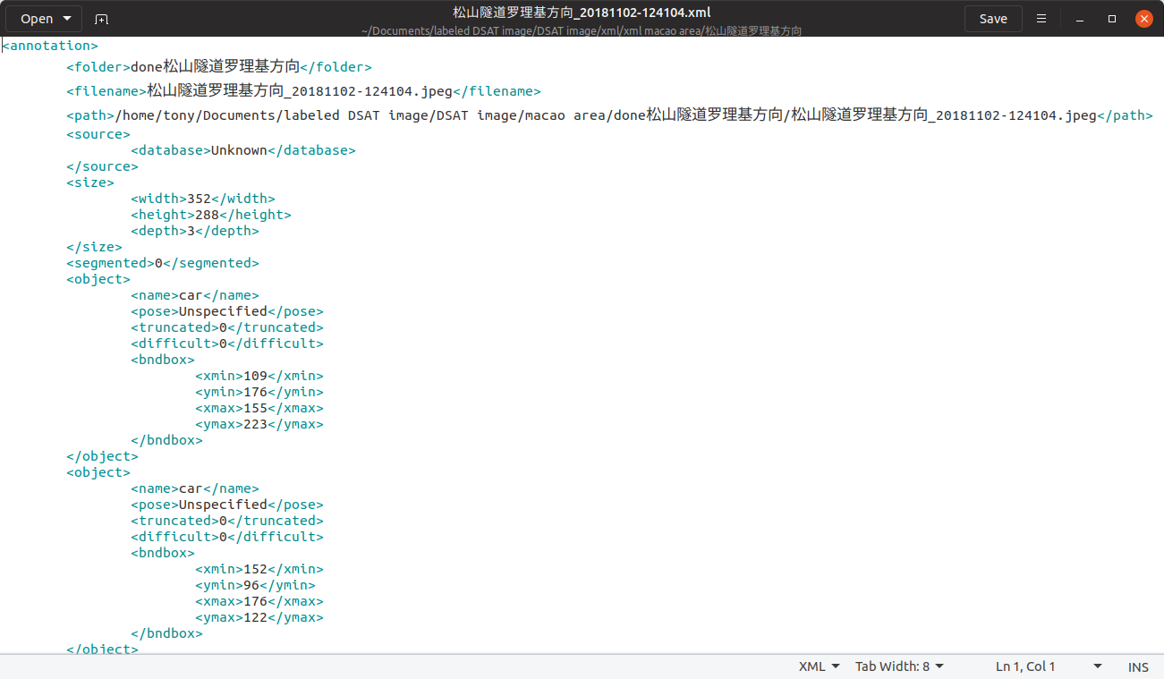

**Figure 21 The annotation files Figure 22 XML format**

Finally, there are 3901 traffic images from the camera of the Tunel do Monte da Guia (the direction of Rodrigo) that have been labeled.

### Creating datasets

The datasets should be created for training and testing object detection models after downloading and labeling traffic images. In this project, there are three datasets which are training dataset, test dataset and validation dataset.

It is clear that the training dataset is used for training models, validation dataset is used to evaluate the models without biases and check if the models overfit the training dataset. The test dataset will be used to test the performance of models.

The total number of labeled traffic images is 3901 in total. The codes (Figure 23) will separate the images into three different datasets. The training dataset consists of 90% of labeled images, which has 3511 labeled traffic images. The test dataset contains 90% of the rest of images and the rest of images will be allocated to validation dataset. Therefore, the number of labeled traffic images in the training dataset, test dataset and validation dataset are 3511, 351 and 39. The annotations fileswhich are in XML format will also be separated according to the three folders.

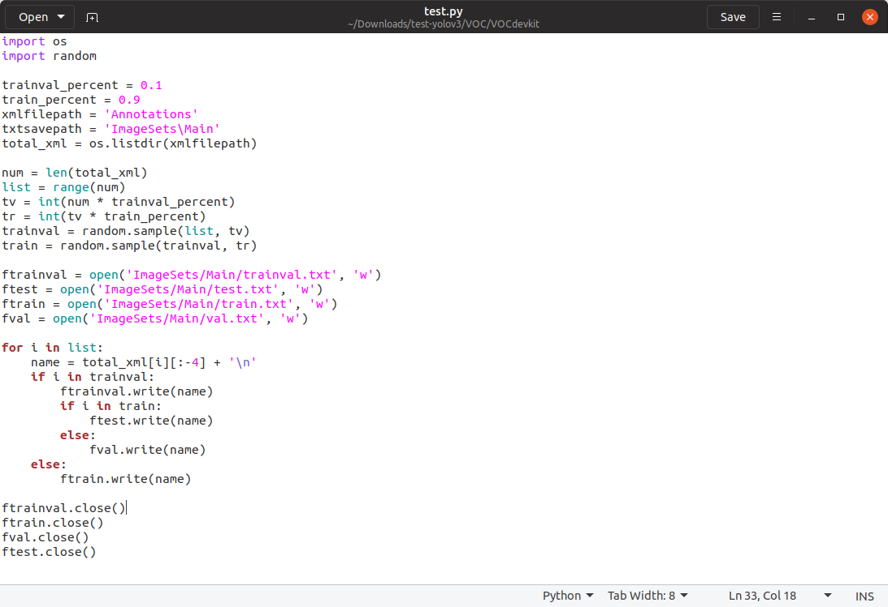

**Figure 23 Codes for creating three models**

After getting three TXT files, which contains the lists of images’ names, the 3901 traffic images should be separated and moved into three folders *train*, *test* and *validation* accordingly. The example codes are shown in Figure 24:

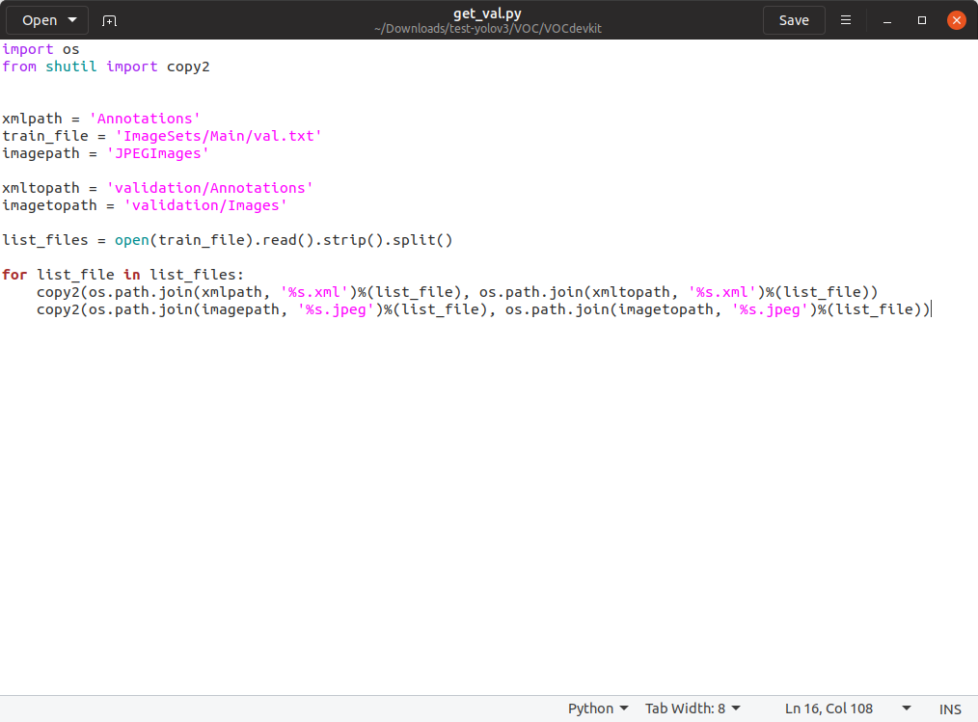

**Figure 24 Get images for validation**

In order to train the models and evaluate performance of models, the XML files will be converted into TXT files which contain ground-truth of bounding boxes and corresponding classes. The codes are shown in Figure 25.

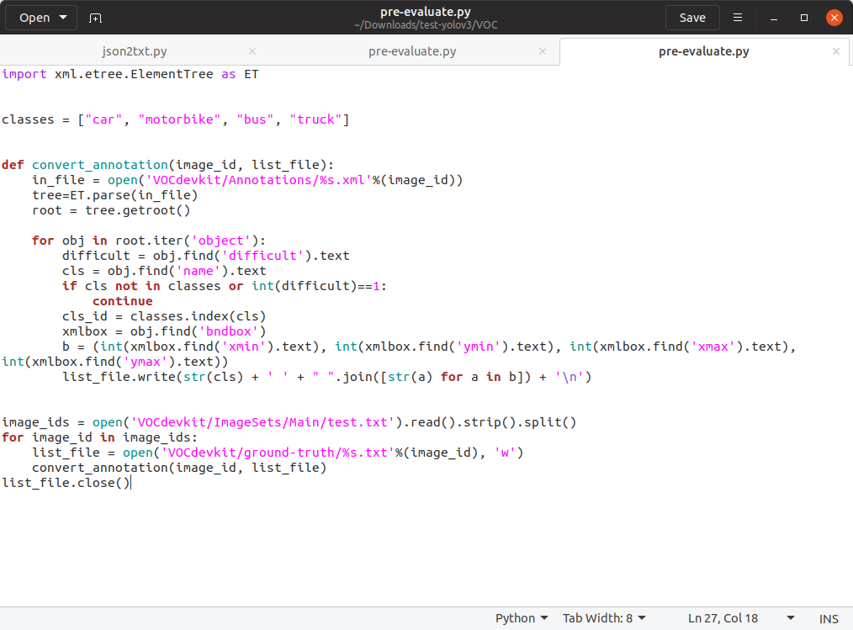

**Figure 25 Codes of XML to TXT**

## Models

In this project, three versions of YOLO models have been explored to solve the traffic problem in Macao. In order to better understand the models and train them, the implementations of YOLO models should be in Python programming language. Thus, darkflow [23] is used for tiny YOLOv2 model and YOLOv2 model. The keras-yolo3 [24] is used for YOLOv3 model. Also, the mAP [25] is introduced to evaluate the performance of models. If the predicted object and ground-truth object share the same label and overlapping area is over 50%, this will be considered as true-positive.

First of all, the prerequisite modules and libraries should be installed correctly. Before testing and training the models, the dependences of models should be built firstly.

|  |
| --- |
| *Install Numpy: sudo pip3 install NumPy*  *Install TensorFlow: pip3 install tensorflow*  *Install Matplotlib: sudo apt-get install python3-matplotlib*  *Install Keras: pip3 install keras* |

After downloading and extracting the darkflow, build the Cython in place by the following codes:

|  |
| --- |
| *python3 setup.py build_ext –inplace*  *pip3 install .* |

Two approaches which have been applied on the three YOLO models. The first approach is using the existing YOLO models and second approach is retraining the existing YOLO models using self-made datasets. These two approaches will be discussed in detail below.

### Tiny YOLOv2 model

Before testing and retraining the tiny YOLOv2 model, the darkflow and mAP should be installed firstly. The original tiny YOLOv2 model is trained on VOC dataset. This model can detect 20 classes.

In order to test the performance of original tiny YOLOv2 model, two files should be downloaded. The first one is the *tiny-yolo-voc.cfg* which is the structure of tiny YOLOv2 model. The second file is the *tiny-yolo-voc.weights* which is the original weights of tiny YOLOv2 model.

Also, The test dataset should be copied to the folder *darkflow/Images* for evaluation.

The following command will perform object detection on the test dataset using the original tiny YOLOv2 model and output the prediction results in JSON format:

|  |
| --- |
| *flow –imgdir Images –model cfg/tiny-yolo-voc.cfg --load bin/tiny-yolo-voc.weights --json* |

Before evaluating mAP performance of model, prediction results in the JSON format is converted to TXT format by the codes below (Figure 20). After that, these TXT files will be moved into the *predicted* folder.

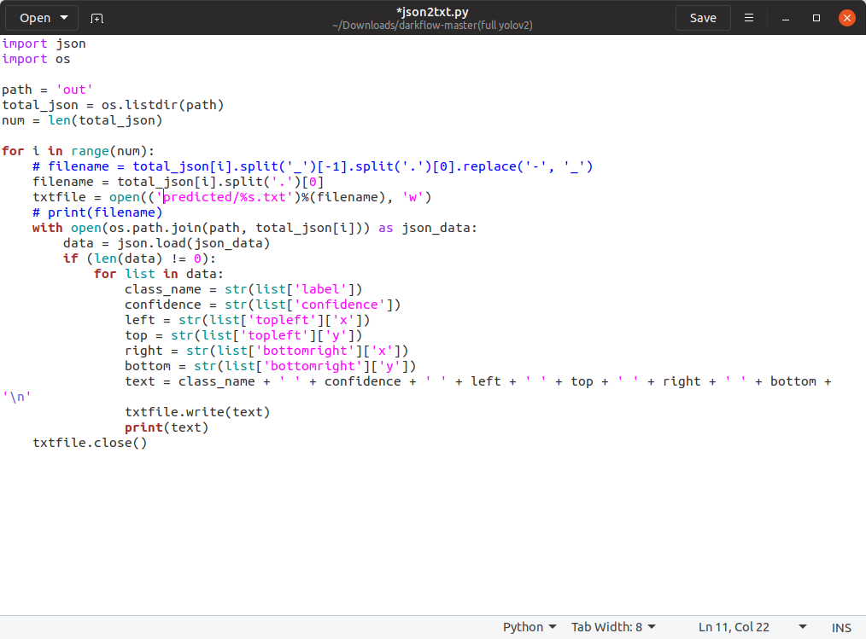

**Figure 26 Codes of JSON to TXT**

In order to calculate mean average precision, the ground truth of test dataset is also needed. Therefore, the folder *ground-truth,* which contains the correct bounding boxes of the test dataset. Both *ground-truth* and *predicted* folders are placed in the folder named *mAP*. The *main.py* in the folder *mAP* will help to calculate mean average precision.

In terms of retraining the tiny YOLOv2 model, the procedures are shown below. The original tiny YOLOv2 model can detect up to 20 different classes, which is much more than needs. Since there are mainly 4 classes on the roads in Macao, the number of prediction classes is constrained to 4.Z Thus, the new copy of *tiny-yolo-voc.cfg* will be created and renamed *tiny-yolo-voc-4c.cfg.* In this cfg file (Figure 27), the *classes* in the last layer is changed to 4 and the *filters* in the previous layer is changed to 45. By doing this way, the tiny YOLOv2 model will predict 4 classes rather than 20 classes.

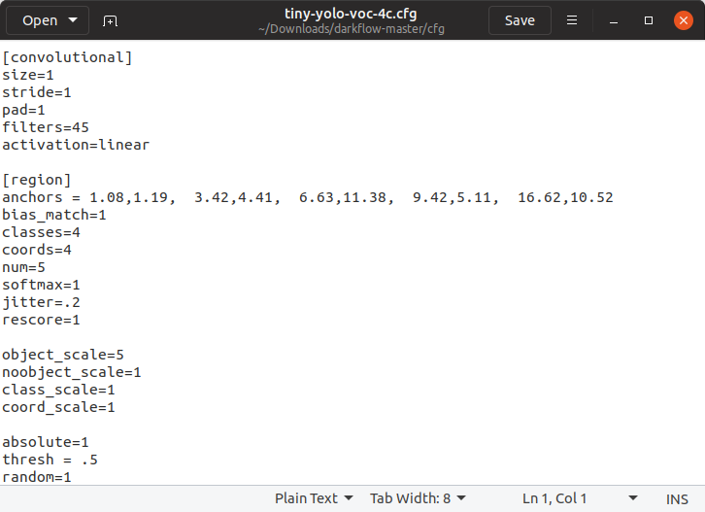

**Figure 27 yolo-voc-4c.cfg**

Secondly, the learning rate, epoch, batch size, score threshold and IoU threshold are set to 1e-5, 100, 64, 0.1 and 0.5 respectively. Finally, the following command will load the original trained weights into the all layers except for the last two layers and retrain the tiny YOLOv2 model:

|  |
| --- |
| *flow –model cfg/tiny-yolo-voc-4c.cfg --load bin/tiny-yolo-voc.cfg --train –dataset train/Images --val_dataset validation/Images --annotation train/Annotations --val_annotation validation/Annotations --epoch 100* |

The same as evaluating the original tiny YOLOv2 model except that the new weights file (checkpoint weights at step 6000) and new cfg file are loaded by the command:

|  |
| --- |
| *flow –imgdir Images –model cfg/tiny-yolo-voc-4c.cfg --load 6000 --json* |

### YOLOv2

The original YOLOv2 model is trained on COCO dataset [26], which can detect 80 classes. The steps of testing and retraining the YOLOv2 model are quite similar to the ones in tiny YOLOv2 model.

After preparing the files for YOLOv2 model, *cfg/yolo.cfg* and *bin/yolo.weights*, the original YOLOv2 model is tested on the same test dataset by the command:

|  |
| --- |
| *flow –imgdir Images –model cfg/yolo.cfg --load bin/yolo.weights –json* |

The JSON files are also converted to the required TXT files. The folders *ground-truth* and *predicted* should be put in place when evaluating the performance of YOLOv2 model. The *main.py* in the folder *mAP* will help to calculate mean average precision.

Before retraining YOLOv2 model, the same configurations should be done. The original YOLOv2 model can detect either 80 classes or 20 classes. The one is trained on the VOC dataset which detects 20 classes are chosen. Because it losses less weights compared to the one with 80 classes after editing the structure of model. This would bring more accuracy and less configurations. the configurations are nearly the same as that in the tiny YOLOv2 model. Firstly, the new cfg file *yolo-voc-4c.cfg* is created. In this cfg file (figure 28), the classes in the last layer is changed to 4 and the filter is changed to 45.

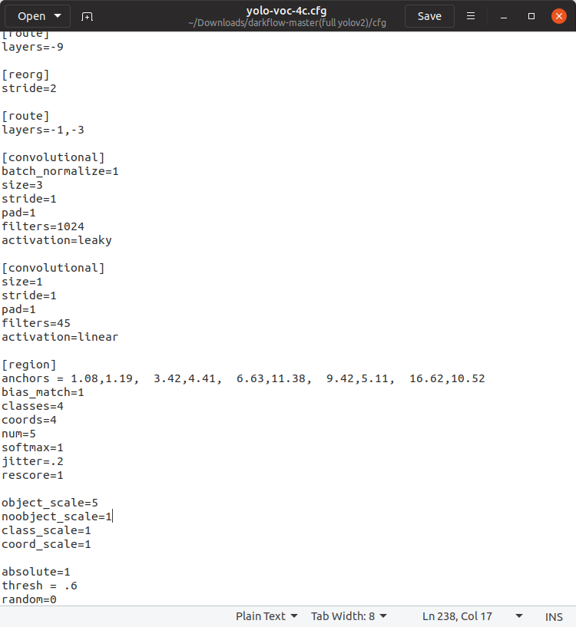

**Figure 28 yolo-voc-4c.cfg**

Secondly, the learning rate, epoch, batch size, score threshold and IoU threshold are set to 1e-5, 100, 32, 0.1 and 0.5 respectively. The following command will load the original trained weights into the all layers except for the last two layers and retrain the YOLOv2 model:

|  |
| --- |
| *flow –model cfg/yolo-voc-4c.cfg --load bin/yolo-voc.cfg --train –dataset train/Images --val_dataset validation/Images --annotation train/Annotations --val_annotation validation/Annotations --epoch 100* |

After retraining the YOLOv2 model, the steps of using mAP are the same as that in the tiny YOLOv2 model except that the new weights file (final checkpoint weights at step 10900) and new cfg file *yolo-voc-4c.cfg* are loaded by the command:

|  |
| --- |
| *flow –imgdir Images –model cfg/yolo-voc-4c.cfg --load 10900 –json* |

### YOLOv3

The same as previous procedures, the performance of original YOLOv3 model should be tested firstly. The original YOLOv3 model which is trained on COCO dataset is chosen in this project for testing. It can detect 80 classes.

Firstly, the weights should be downloaded from the official website by this command:

|  |
| --- |
| *wget https://pjreddie.com/media/files/yolov3.weights* |

After that, the cfg file and weights file should be converted to h5 file by the command:

|  |
| --- |
| *python3 convert.py yolov3.cfg yolov3.weights model_data/yolo.h5* |

The keras-yolo3 only supports detection on one single image at a time. So, the original detection program *yolo_video.py* is edited to support multi-image detection. The new program (Figure 29) is saved in *yolo_video_file.py.*

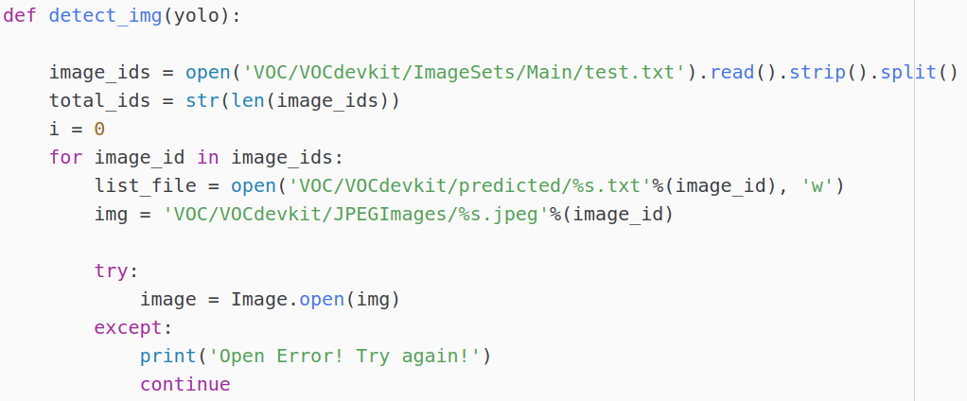

**Figure 29 yolo_video_file.py**

After that, the YOLOv3 model can detect objects on test dataset by the command:

|  |
| --- |
| *python3 yolo_video_file.py --image* |

This will generate the results in TXT format. These TXT files can be used directly for calculating mean average precision.

In terms of retraining YOLOv3 model, some changes have to be made. There are only 4 classes in this project. The new *classes.txt* is created (Figure 30), which contains the name of 4 classes.

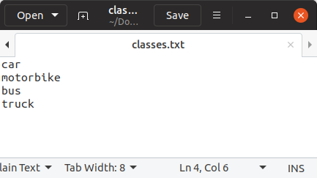

**Figure 30 classes.txt**

Because of the limited computing resources, only last 3 layers are trained (Figure 31). The learning rate, epoch, batch size, score threshold and IoU threshold are set to 1e-3, 100, 48, 0.3 and 0.45 respectively. In the *train.py*, the parameters are set in Figure 32.

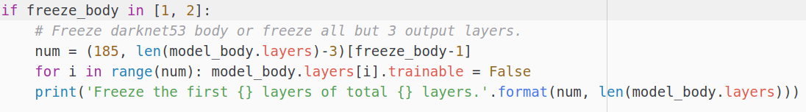

**Figure 31 Codes for training only on last 3 layers**

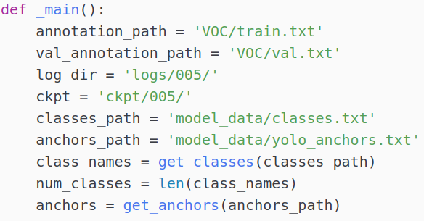

**Figure 32 train.py**

Retraining the YOLOv3 model by the command:

|  |
| --- |
| *python3 train.py* |

The retrained model and weights are saved as *trained_3511.h5* and *trained_weights_3511.h5* respectively.

For testing the performance of the newly retrained YOLOv3 model, certain inputs in the *yolo.py* should be replaced. The configurations are set as the Figure 33:

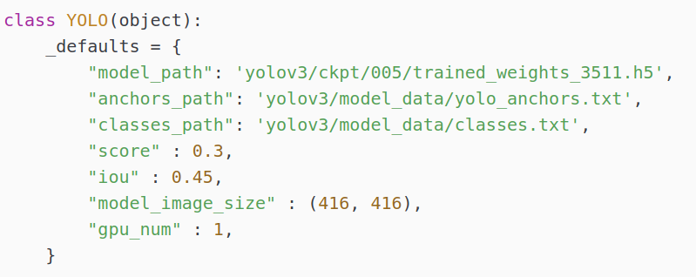

**Figure 33 yolo.py**

The same as detecting the objects using original YOLOv3 model, the *yolo_video_file.py* is also used to generate the prediction results in the same test dataset. The procedures of calculating mean average precision are the same as above.

## Web application

The web application shows the real-time images from the DSAT website and prediction results of three retrained YOLO models.

First of all, the web server should be built. Because all the three object detection models are written in Python, it would be better to choose a web server framework for Python to call these three models. Flask is chosen to build the web server. Before setting up Flask application, the venv module in Python3 is used to create the virtual environment in the folder *myProject.* The command is:

|  |
| --- |
| *python3 -m venv venv* |

Secondly, activate the virtual environment by the command:

|  |
| --- |
| *. venv/bin/activate* |

Thirdly, install Flask in the activated virtual environment by the command:

|  |
| --- |
| *pip3 install Flask* |

In terms of website, it should provide the user-friendly and informative interface. There are more than 40 buttons which provide real-time traffic images from different roads in Macao (Figure 34), Ponte (Figure 35) and Taipa & Coloane (Figure 36).

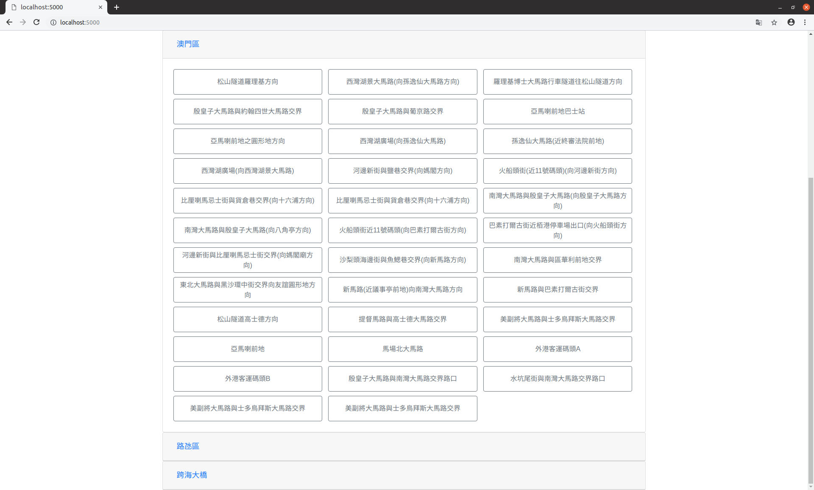

**Figure 34 Macao**

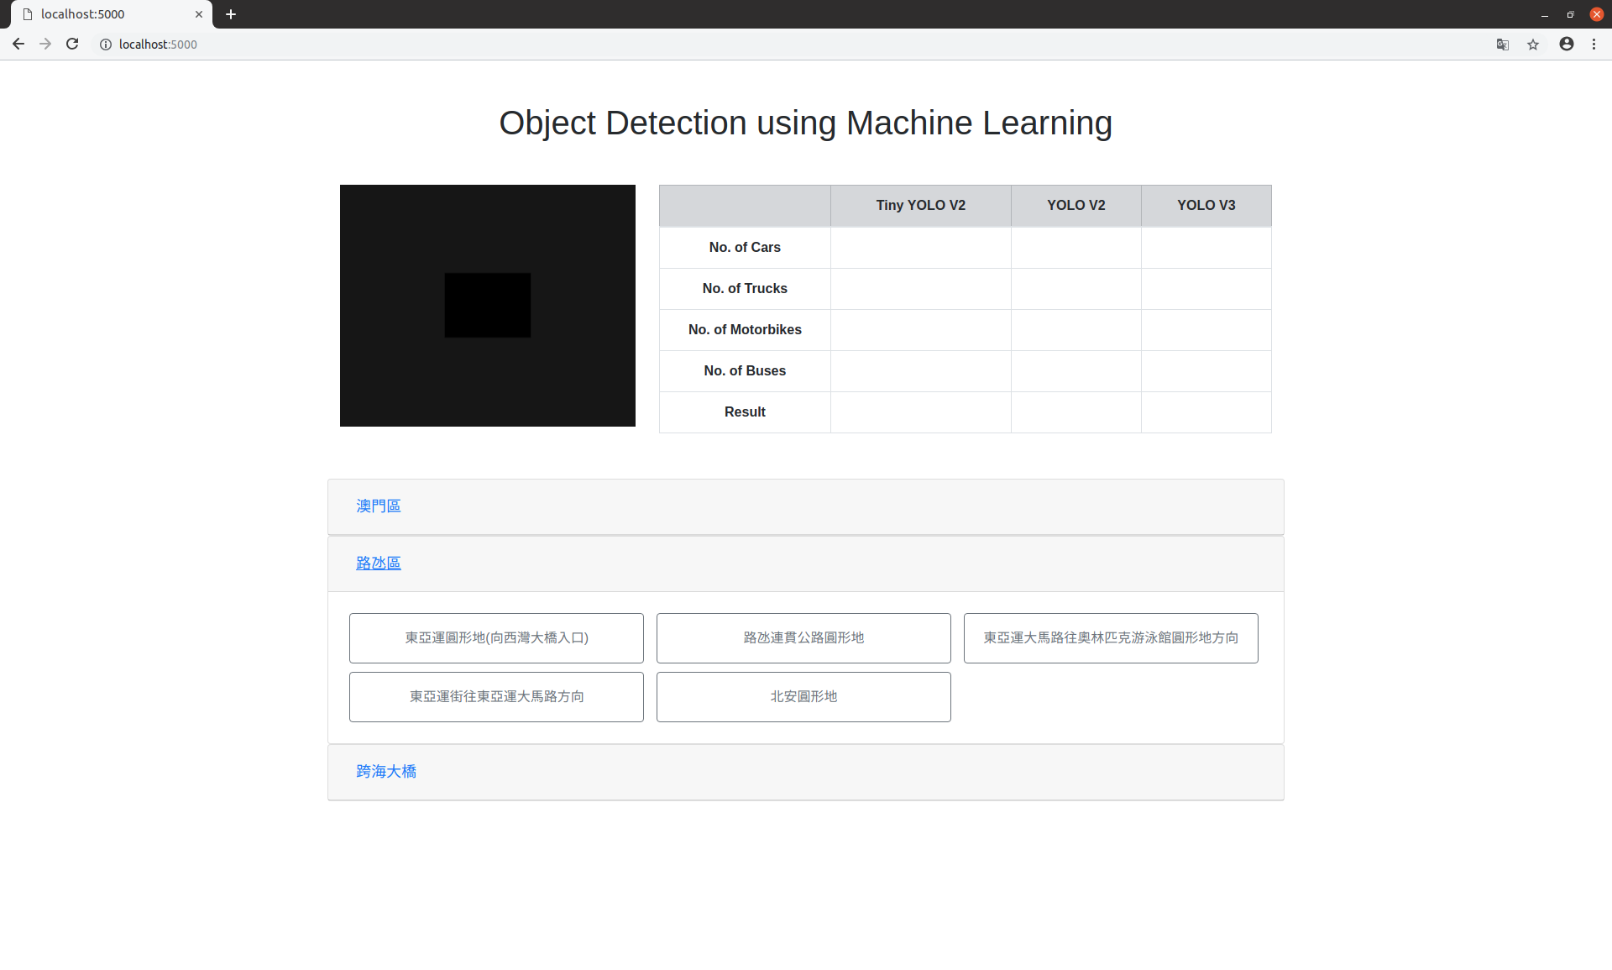

**Figure 35 Ponte**

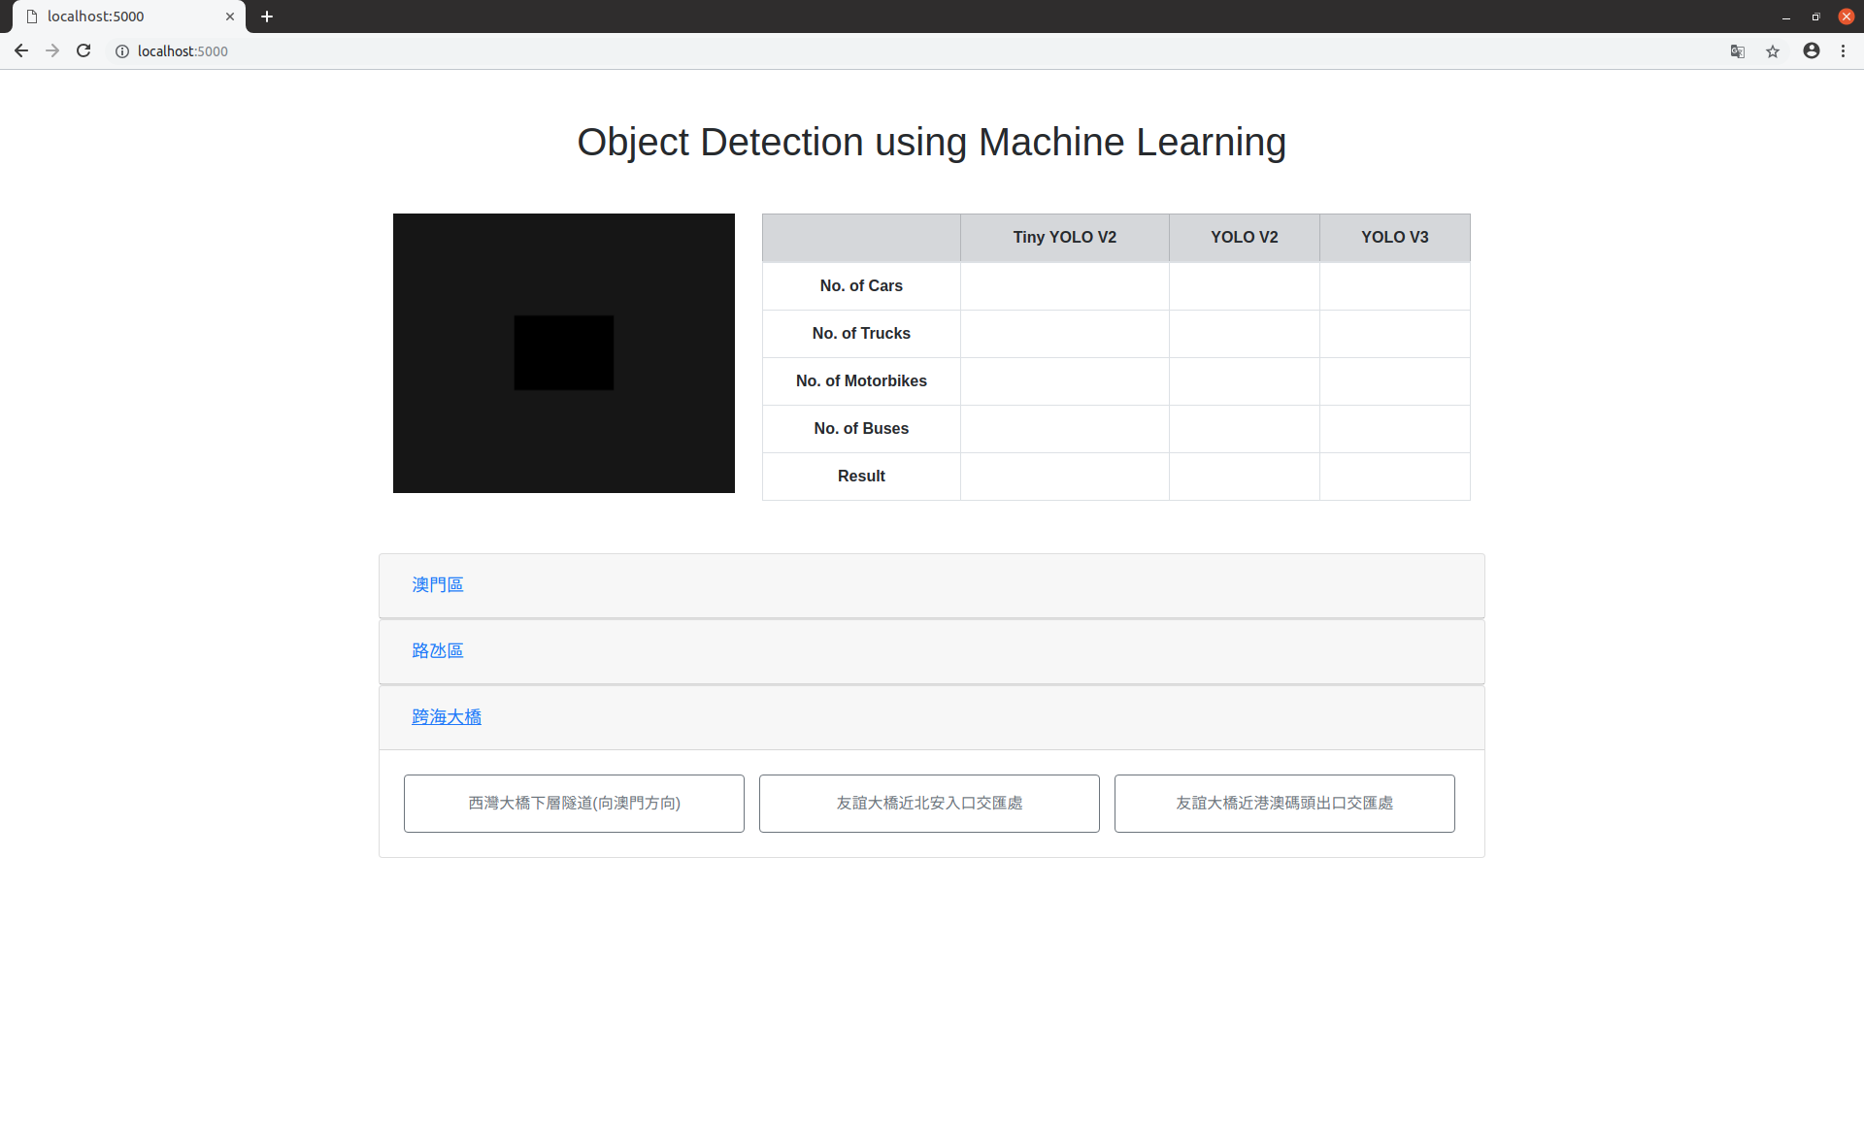

**Figure 36 Taipa & Coloane**

After user clicks one of buttons in the website, the web server will try to obtain corresponding real-time traffic images from the DSAT website every 5 seconds. The method of obtaining traffic images here is quite similar to crawl traffic images above. By passing particular URL with the unique ID of traffic camera, the web server can obtain the real-time traffic images from the given URL (Figure 37).

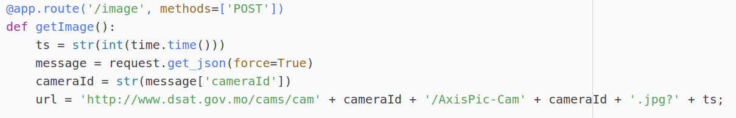

**Figure 37 Codes for obtaining real-time traffic images**

Before returning the downloaded data from the DSAT website, the program will check if the downloaded data is JPEG image and the status code is 200 (Figure 38).



**Figure 38 codes for checking**

If the web server can get the image from the DSAT website successfully, it will return the base64 encoded image data (Figure 39) which can be used directly in HTML <img> tag.

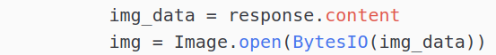

**Figure 39 codes for encoding**

Otherwise, it will return ‘error’ and display the loading image (Figure 40).

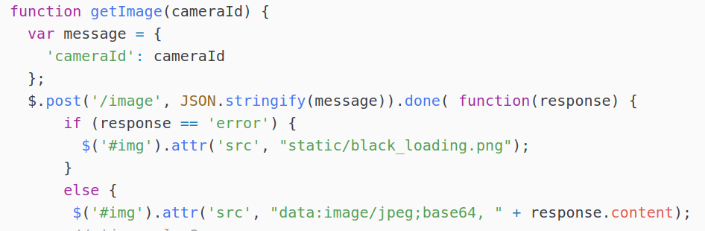

**Figure 40 Codes for error checking**

Because the DSAT website updates its traffic images every 5 seconds, the website will try to get the traffic image of specific location from the DSAT website after clicking this button. This function is achieved by the JavaScript file *script.js* in the folder *static*. After clicking the button, *setInterval* function is used to obtain traffic images every 5 seconds (Figure 41).



**Figure 41 setInterval function**

If the user chooses another traffic camera, the interval will be cleared (Figure 42).

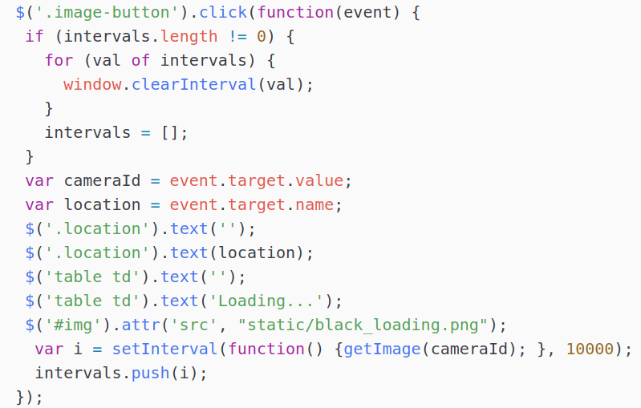

**Figure 42 Codes for cleaning interval**

The web server should also provide the function of detecting vehicles using three retained YOLO object detection models. *main.py* will help to do the prediction on the same traffic image using three retrained models.

The parameters of two YOLOv2 models are defined as in Figure 43:

  
**Figure 43 Parameters of two YOLOv2 models**

After that, the two YOLOv2 models are loaded (Figure 44):

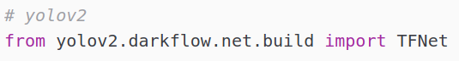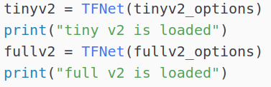

**Figure 44 Load two YOLOv2 models**

The prediction using the two retrained YOLOv2 models can be done by the following codes in Figure 45.

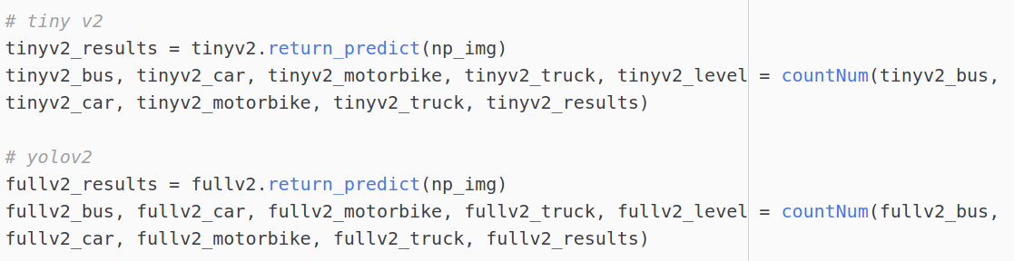

**Figure 45 Predict vehicles using twoYOLOv2 models**

In order to load the YOLOv3 model and predict on the traffic images at real-time. The new program *yolo_image.py* is created (Figure 46).

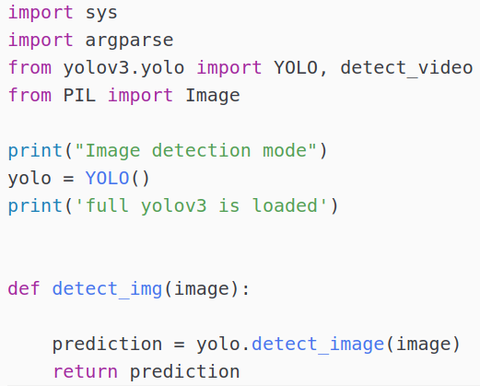

**Figure 46 yolo_image.py**

The YOLOv3 model can be loaded by the codes in Figure 47:

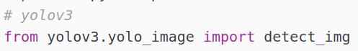

**Figure 47 Load YOLOv3 model**

This figure shows how to call the YOLOv3 model to detect objects as Figure 42:

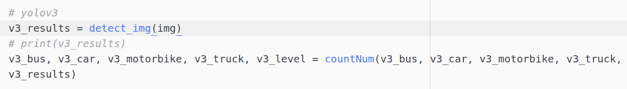

**Figure 48 predict vehicles using YOLOv3 model**

The Flask web server returns analysis and the number of cars, buses, motorbikes and trucks which are predicted by the three models (Figure 49).

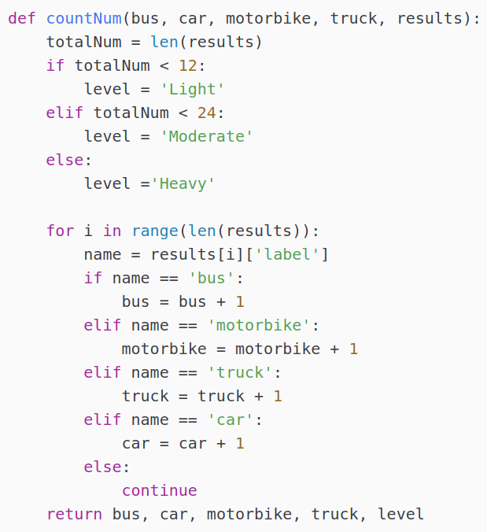

**Figure 49 countNum function**

If the total number of total vehicles is smaller than 12, the congestion level is light. If the total number of total vehicles is between 12 and 24, the congestion level will be Moderate. Otherwise, the congestion level is heavy.

Finally, run the Flask in the virtual environment by the command.

|  |
| --- |
| *FLASK_APP=main.py flask run* |

# Results and Discussion

## Testing environment

|  |  |  |  |
| --- | --- | --- | --- |
|  | Tiny YOLOv2 model | YOLOv2 model | YOLOv3 model |
| No. of epochs | 100 | 100 | 100 |
| Learning rate | 1e-5 | 1e-5 | 1e-3 |
| Batch size | 64 | 32 | 48 |
| Score threshold | 0.1 | 0.1 | 0.3 |
| IoU threshold | 0.5 | 0.5 | 0.45 |
| Full retraining? | Yes | Yes | No(only last 3 layers) |

After training three object detection models, the comparisons between tiny YOLOv2 model, YOLOv2 model and YOLOv3 model on training dataset (3511 traffic images) with annotations before and after training are made and analyzed clearly. The table below summaries the details of three retrained YOLO models.

**Table 2 Summary of three retrained YOLO models**

## Comparison before and after retraining

### Tiny YOLOv2

The tiny YOLOv2 model has much smaller networks than YOLOv2 model as it only contains 9 convolutional layers and 6 maxpooling layers. The original tiny YOLOv2 model is trained on VOC dataset. It can detect 20 classes.

Before retraining tiny YOLOv2 model, the performance of original model should be tested. In the test dataset containing 351 traffic images, the prediction accuracy of the original YOLOv2 is extremely low (Figure 50).

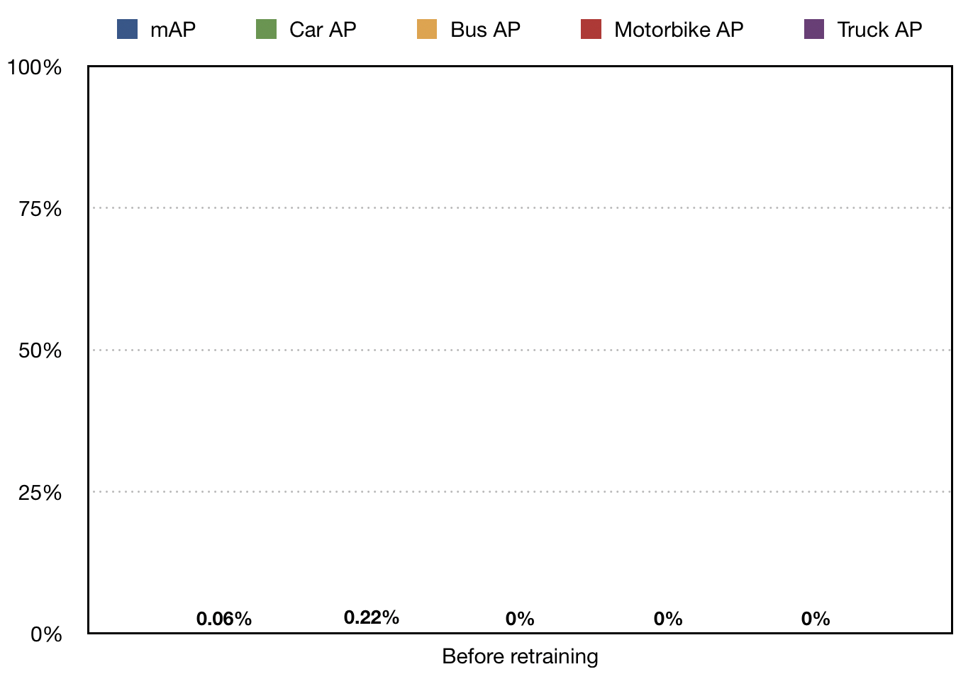

**Figure 50 Bar chart of tiny YOLOv2 model**

The mean average precision only achieves 0.06%. Even though the Car AP has the highest percentage among them, it only has 0.22% while the other three classes stand at 0%. The terrible results show that the model is poor at recognizing objects and predicting locations of objects.

After retraining the tiny YOLOv2 model using training datasets, the average precision of all classes increases dramatically (Figure 51). Also, the training loss and validation loss can be seen in Figure 52 and Figure 53.

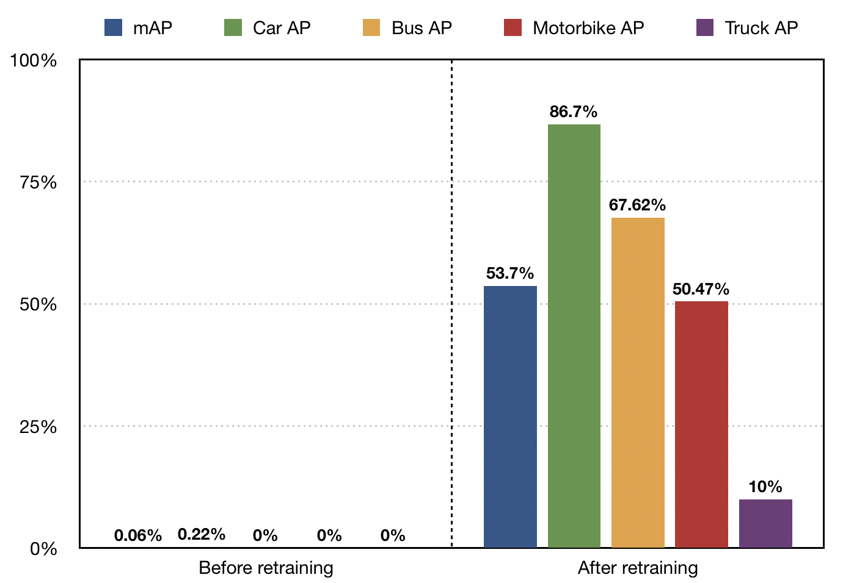

**Figure 51 Bar chart of retrained YOLOv2 model**

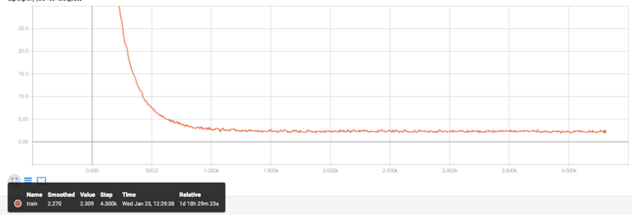

**Figure 52 Training loss of tiny YOLOv2 model**

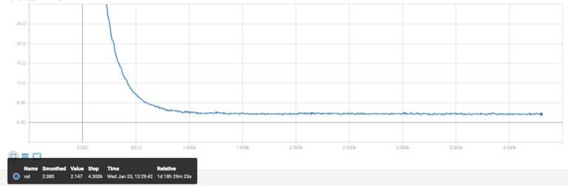

**Figure 53 Validation loss of tiny YOLOv2 model**

The mAP on the same test dataset soars to 53.7%. The car AP has the greatest improvement among all classes. The figure rises from 0.22% to 86.70%. The other classes can also see significant improvement. The accuracy percentage of motorbike and bus goes up to 67.62% and 50.47% respectively. The least increase can be seen in truck AP, which increases to 10%.

### YOLOv2

The original YOLOv2 model has 19 convolutional layers, 5 max pooling layers and 1 global average pooling. The network is much bigger than the tiny YOLOv2 model. This original YOLOv2 model is trained on COCO dataset, which can detect 80 different classes. The overall prediction accuracy should be better than the tiny YOLOv2 model.

The average precision of the original YOLOv2 model should be evaluated firstly. The results are shown in Figure 54.

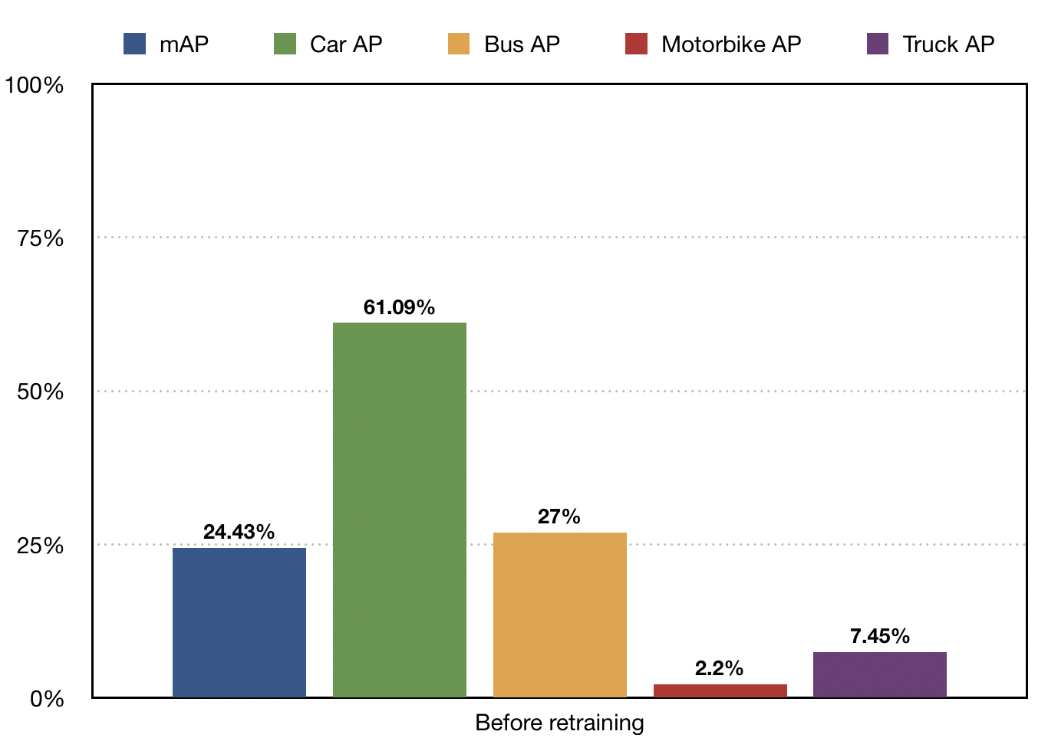

**Figure 54 Bar chart of YOLOv2 model**

During retraining, the training loss and validation loss can be seen in Figure 55 and Figure 56. After retraining the model, almost all APs of classes increased rapidly (Figure 57).

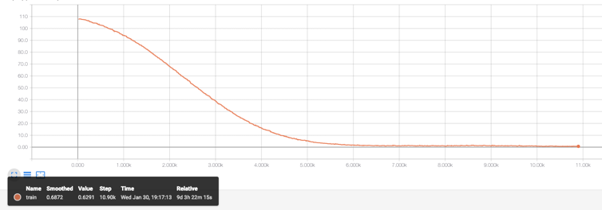

**Figure 55 Training loss of YOLOv2 model**

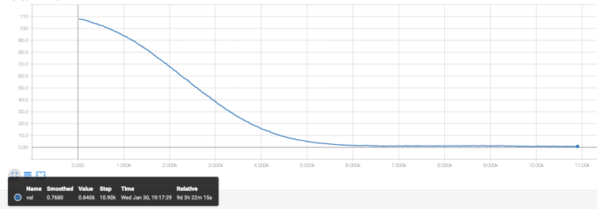

**Figure 56 Validation loss of YOLOv2 model**

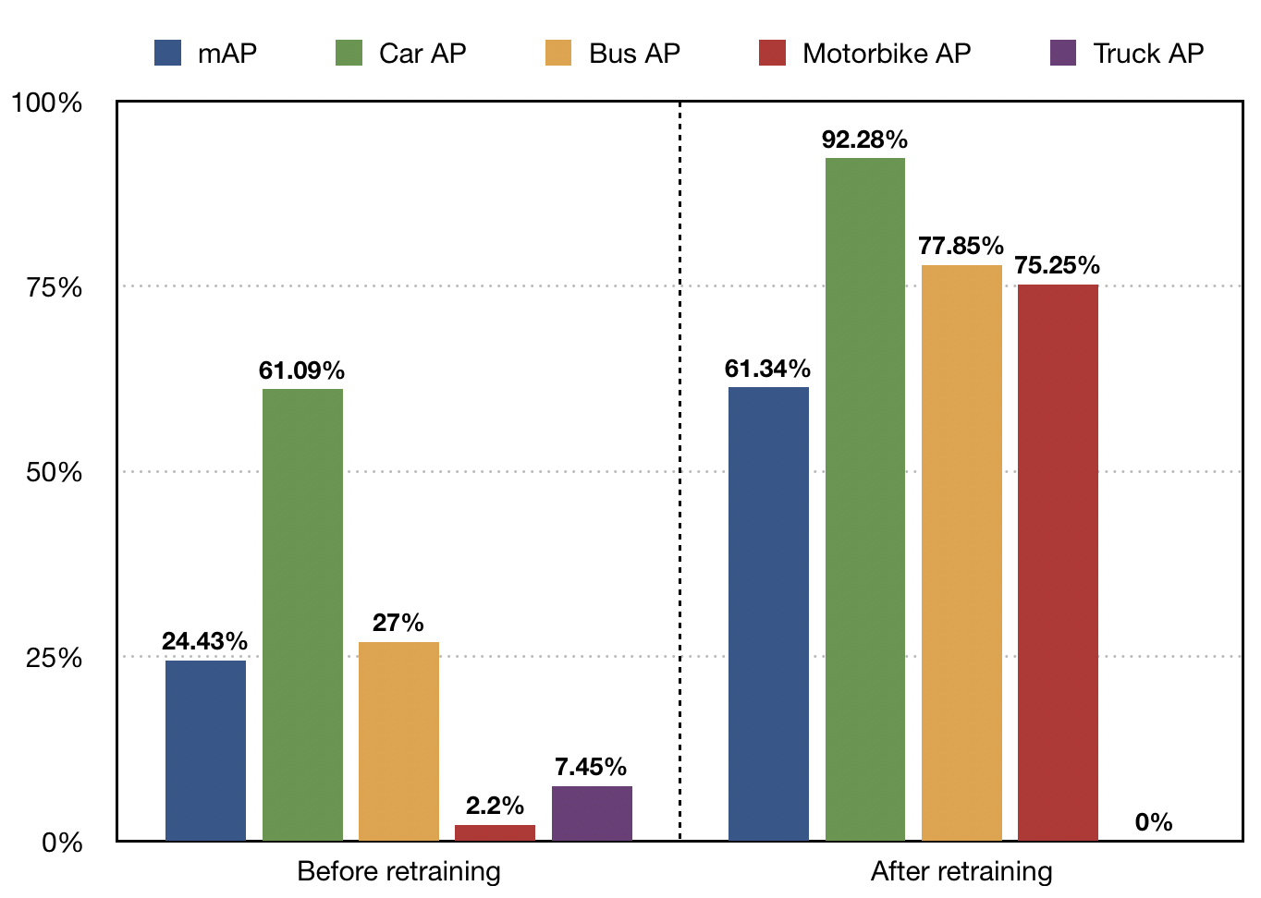

**Figure 57 Bar chart of retrained YOLOv2 model**

Compared to tiny YOLOv2 model, the mAP is much higher on the same test dataset, which stands at 24.43%. The main contributor to the mAP is the car AP. Its percentage stands at 61.09%. The second highest figure is the bus AP which achieves 27.00%. As for the motorbike AP and truck AP, the figures are 2.20% and 7.45% respectively.

The mAP rises rapidly to 61.34%. The main contributor is still the car AP, which jumps to 92.28%. The second highest (bus AP) and third highest (motorbike AP) are quite close. The figures are 77.85% and 75.28% respectively. The three classes (car, bus and motorbike) also see a noticeable increase especially motorbike AP. However, it is unexpected that the YOLOv2 model cannot detect any truck correctly after retraining.

### YOLOv3

The YOLOv3 model is the latest version of YOLO object detection model. It contains 59 convolutional layers which are much bigger than any previous versions of YOLO object detection model. The same as the YOLOv2 model, the YOLOv3 model is trained on COCO dataset which can detect 80 different classes.

In the same test dataset, the original YOLOv3 object detection model has the highest mAP among these three models (Figure 58).

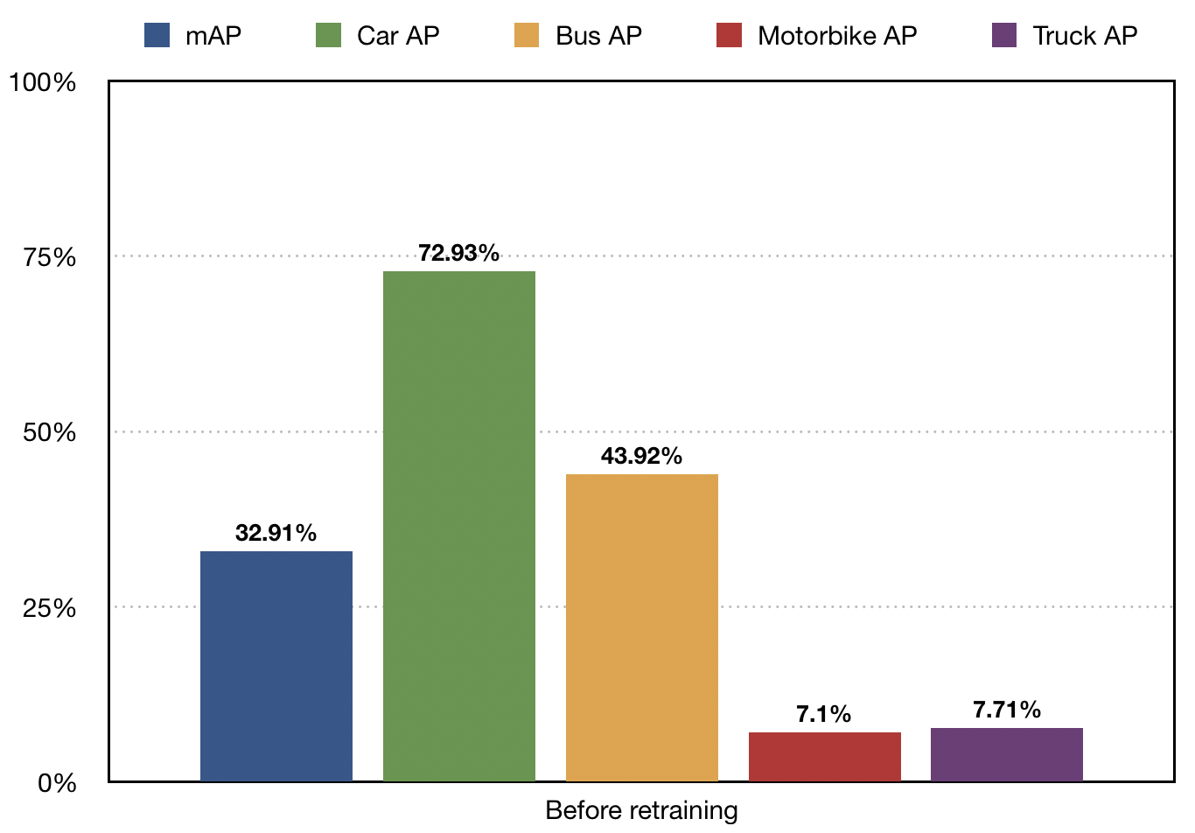

**Figure 58 Bar chart of YOLOv3 model**

The mAP is up to 32.91% which is 10% higher than that of original YOLOv2 object detection model. The car AP can stand at just below 75% and the bus AP has 43.92%. It is clear that the motorbike AP and truck AP have similar figures (7%).

During retraining, the training loss and validation loss can be seen in Figure 59 and Figure 60. After retraining the last 3 layers of YOLOv3 model, almost all APs of classes rose (Figure 61).

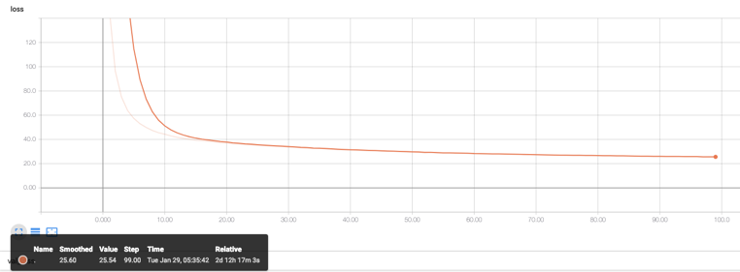

**Figure 59 Training loss of YOLOv3 model**

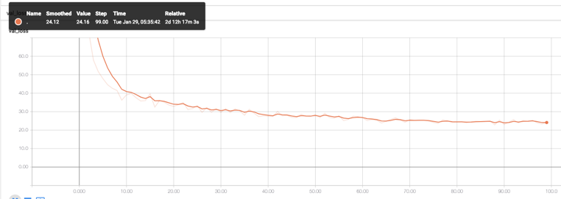

**Figure 60 Validation loss of YOLOv3 model**

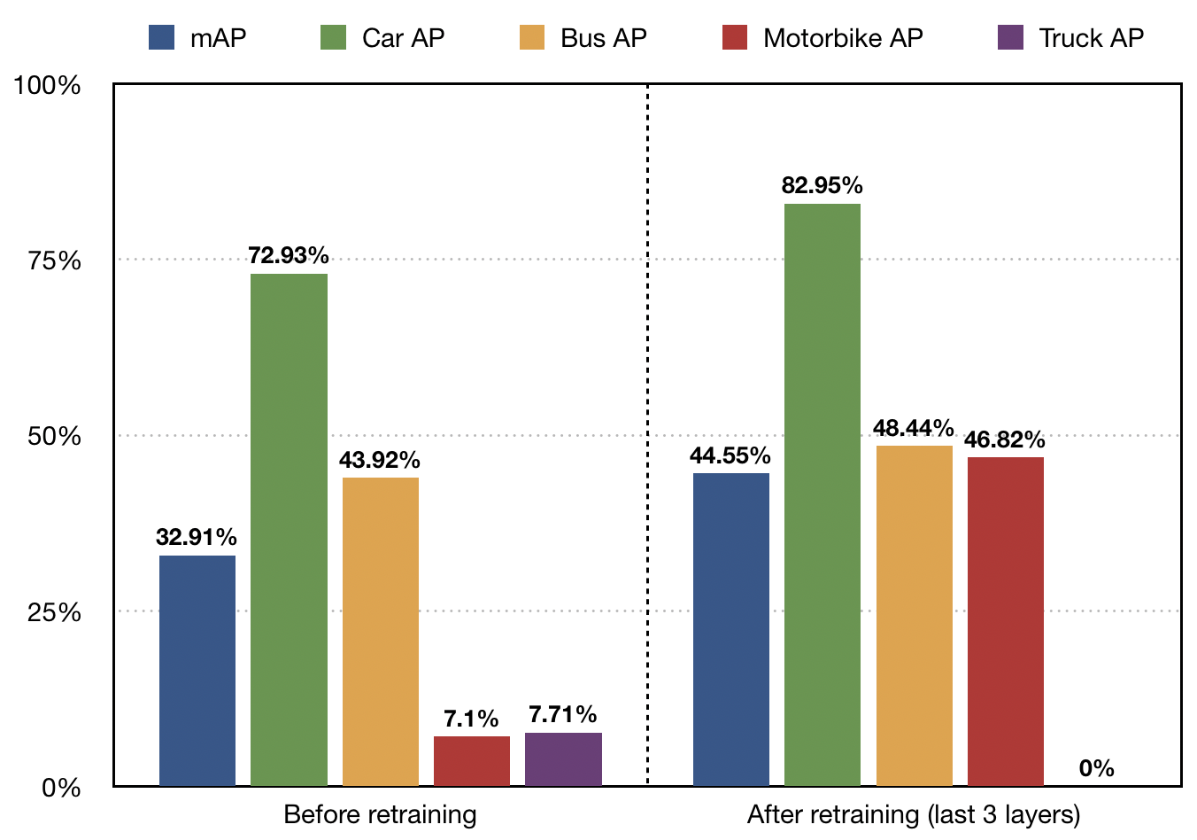

**Figure 61 Bar chart of retrained YOLOv3 model**

Compared to YOLOv2 model, the mAP is surprising lower in the same test dataset, which achieves at 44.55%. The car AP and the bus AP can still see increase. The car AP increases 10.02% and the bus AP rises about 5%. But the biggest increase can be shown in the figure of motorbike AP, which rises significantly from 7.10% to 46.82%. The same situation happens in YOLOv3 model, the truck AP drops to 0%.

## Comparison between three models

### Before training

The performance of all three original YOLO object detection models can be seen in the figure 62. Before training the three models, the YOLOv3 model has highest prediction accuracy of all classes. The mAP of YOLOv3 model is almost 10% higher than that of YOLOv2 model. It is unfortunate to notice that the tiny YOLOv2 model has almost zero prediction accuracy in prediction objects.

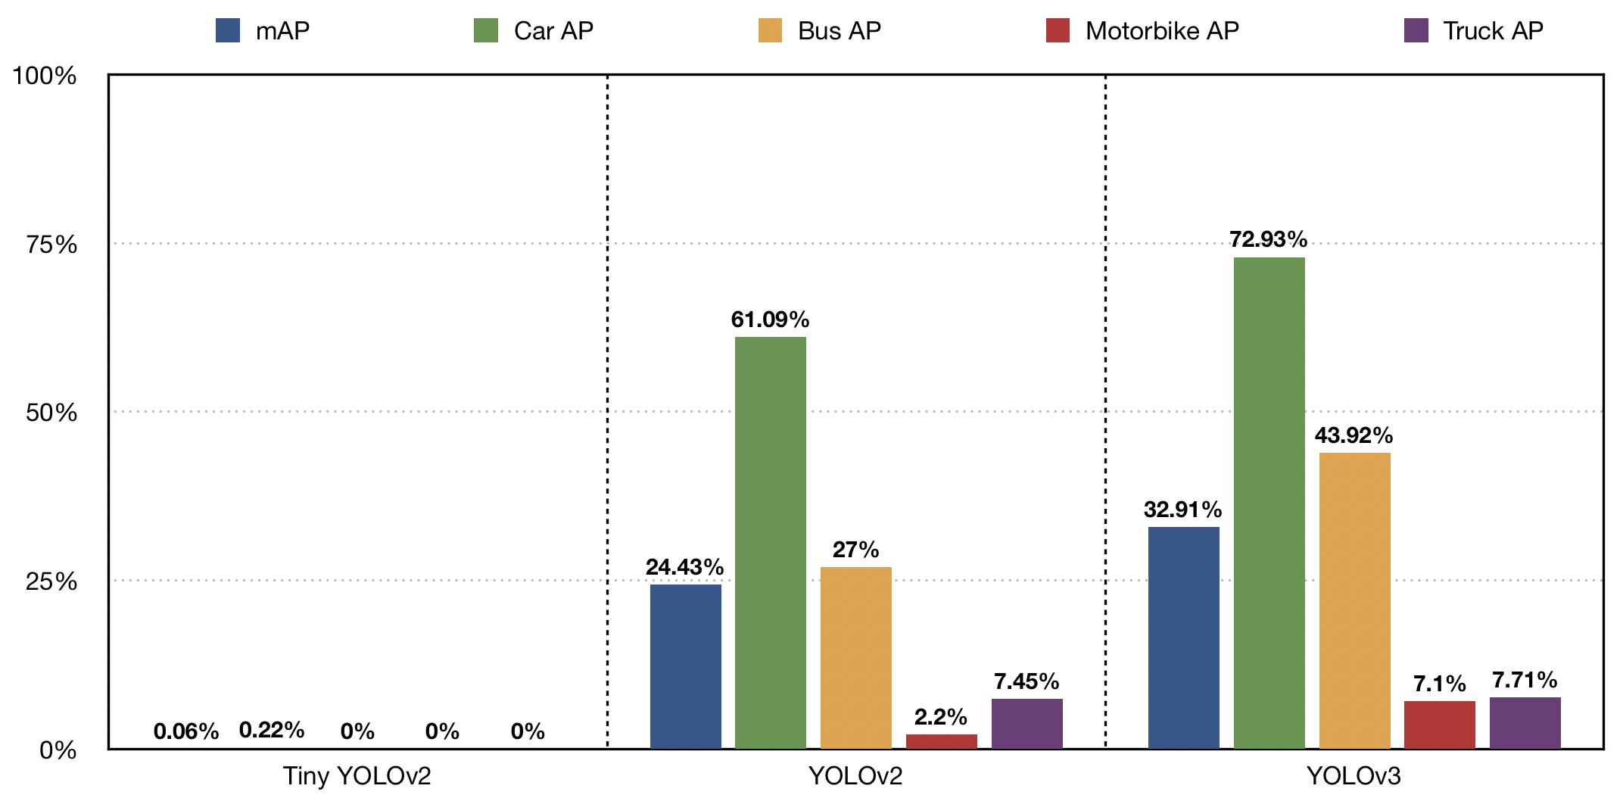

**Figure 62 Three original YOLO models**

The following figures are the two traffic images with bounding boxes using three original YOLO models.

For the first traffic image with light congestion level,

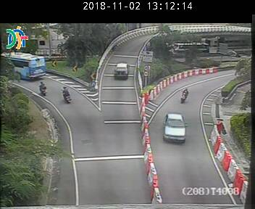 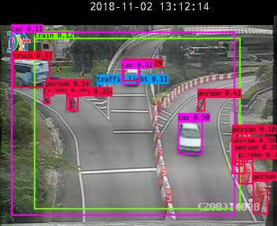 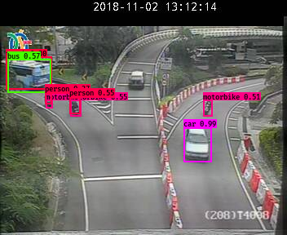

**Figure 63 Tiny YOLOv2 (light) Figure 64 YOLOv2 (light) Figure 65 YOLOv3 (light)**

For the second traffic image with heavy congestion level:

 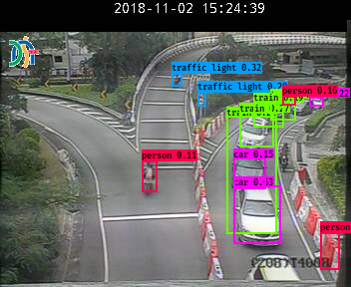 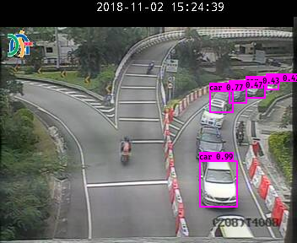

**Figure 66 Tiny YOLOv2 (heavy) Figure 67 YOLOv2 (heavy) Figure 68 YOLOv3 (heavy)**

Tiny YOLOv2 model: It cannot detect any vehicles on both traffic images.

YOLOv2 model: Even though the most of cars are labeled correctly, there are still many mislabeled vehicles on the traffic images: The motorbikes and the traffic barriers are labeled as persons or traffic lights; the bus is labeled as truck.

YOLOv3 model: The multilabel classification mechanism in YOLOv3 model allows it to detect vehicles more accurately. The buses, motorbikes and cars are labeled correctly. However, some cars are unlabeled, motorbikes are also labeled as persons and the bus is labeled as truck.

### After retraining

After retraining the tiny YOLOv2 model, YOLOv2 model and the last 3 layers of YOLOv3 model, the average precision of all classes have improved noticeably (Figure 70).

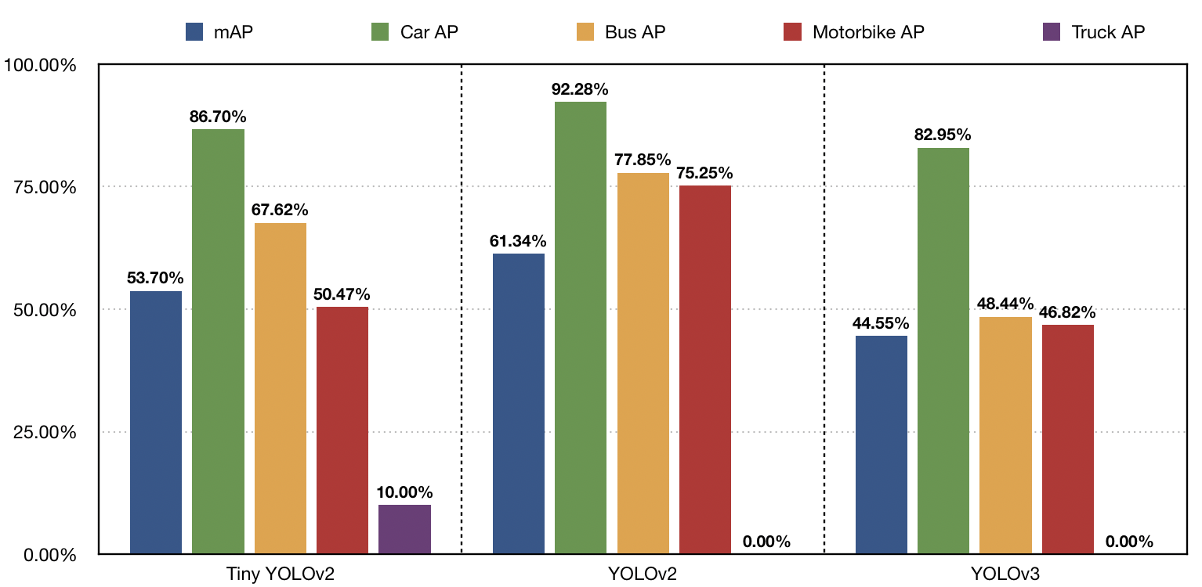

**Figure 69 Three retrained YOLO models**

It is interesting to see that the YOLOv2 model has the best performance in detecting objects on the DSAT images. The mAP of YOLOv2 model is almost 20% larger than the one of YOLOv3 model. There are several reasons behind the situation. Firstly, after retraining the YOLOv3 model in 100 epochs, the training loss has not converged yet, the number of epoch should be larger. Secondly, only last 3 layers are retrained, and the weights of all other layers are preloaded from original weights. These lead to slow convergence.

The following figures are the two traffic images with bounding boxes using three retrained YOLO models.

For the first traffic image with light congestion level,

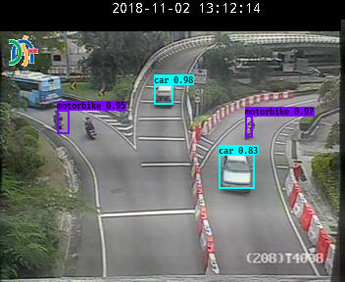 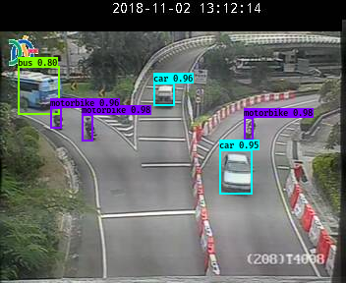 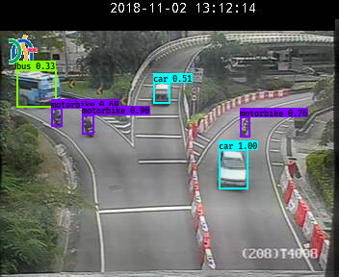

**Figure 70 Tiny YOLOv2 (light) Figure 71 YOLOv2 (light) Figure 72 YOLOv3 (light)**

For the first traffic image with heavy congestion level,

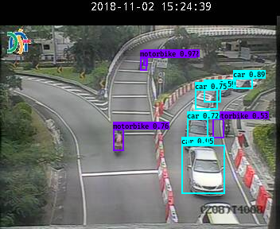 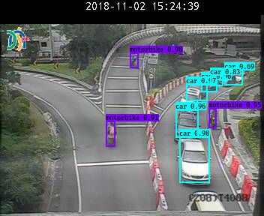 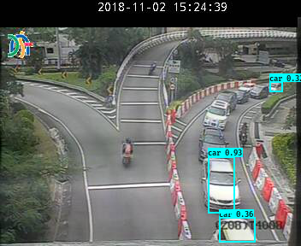

**Figure 73 Tiny YOLOv2 (heavy) Figure 74 YOLOv2 (heavy) Figure 75 YOLOv3 (heavy)**

Tiny YOLOv2 model: After retraining, the tiny YOLOv2 model can detect vehicles pretty well with high confidence. Although it cannot detect some of vehicles and the localization of motorbikes is not perfect.

YOLOv2 model: The retrained YOLOv2 model has excellent performance. All the vehicles are labeled correctly with high confidence.

YOLOv3 model: The retrained YOLOv3 model extends its high performance from original one. However, the detection performance is worse than the retained YOLOv2 model.

## Web application

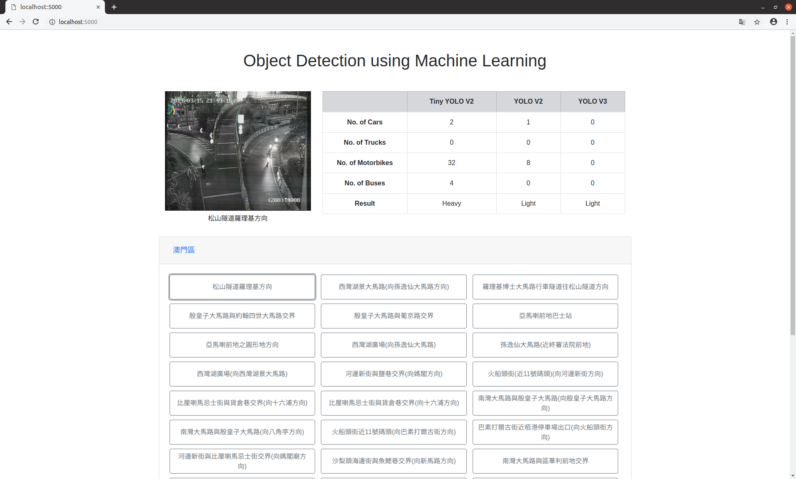

**Figure 76 web application**

Once the user chooses one of the locations by clicking the button, the real-time traffic image and the number of each vehicle which are predicted by the three object detection models are shown in the webpage. Tiny YOLOv2 model, YOLOv2 model and YOLOv3 model process the traffic images and predict the volume of vehicles at the real time. It also provides the analysis of traffic flow according the total number of vehicles. If the total number is less than 12, the traffic congestion level is light. If the total number is between 12 and 24, the traffic congestion level is moderate. Otherwise, the traffic congestion level will be heavy.

# Conclusion and Further Work

## Conclusion

In this project, the three versions of YOLO object detection model have been explored to fit in Macao. More than 60,000 traffic images have been downloaded from different traffic cameras in the DSAT website. The self-made datasets which contain annotations are built from scratch. The training dataset contains 3511 labeled traffic images, the test dataset contains 351 labeled traffic images and the validation dataset consists of 39 labeled traffic images. In order to improve the prediction accuracy of three original object models, the three models have been retrained.

After retraining the three models in 100 epochs, the mean average precision of tiny YOLOv2 model can achieve 53.7%. The mAP of YOLOv2 model can go up to 61.34% which is the highest among three retrained YOLO models.

In addition, the web application is built for commuters to have better ideas about the current traffic congestion level.

## Further work

The further work is discussed in terms of datasets, models and web application.

### Datasets

Ideally, the datasets should contain many and different kinds of traffic images which are from different cameras. However, drawing bounding boxes for each object on each traffic image is time-consuming and tedious, the all datasets used in this project are from the same place and have only 4001 labeled traffic images. The more diversity and volume of labeled traffic images should bring more robust and powerful models.

### Models

The YOLOv3 model should have been well-trained. In this project, original YOLOv3 model have better performance than the original YOLOv2 model. However, the YOLOv2 model exceeds the YOLOv3 model after training. Due to the limited computing capability and time, only last 3 layers of YOLOv3 model are trained. In order to train good YOLOv3 model, the more computing resources should be provided. Also, the YOLOv3 model uses 3 scales to detect objects. The layers should be well selected to train rather than choosing the last 3 layers. The YOLOv3 model has 59 convolutional layers. Therefore, the training time should be longer. Lastly, the sizes of anchor boxes are chosen by K-means clustering in the VOC dataset and COCO dataset. The prediction accuracy may be improved by choosing new anchor boxes using K-means clustering according to the traffic images from the DSAT website.

### Web application

The Flask is used to build the web server. However, the Flask is the micro web framework which is good enough to serve the requests when there are only one or two users. If the web application is launched to public, the more powerful web server should be used.

References

[1] J. Redmon, S. Divvala, R. Girshick, and A. Farhadi. You Only Look Once: Unified, Real-Time Object Detection. arXiv preprint arXiv: 1506.02640, 2015.

[2] J. Redmon, A. Farhadi. YOLO9000: Better, Faster, Stronger. arXiv preprint arXiv: 1612.08242, 2016.

[3] J. Redmon, A. Farhadi. YOLOv3: An Incremental Improvement. arXiv preprint arXiv: 1804.02767, 2018.

[4] Transport Bureau of the Macao S.A.R.. http://www.dsat.gov.mo, 2015 [Nov. 11, 2018].

[5] G. van Rossum, Python tutorial, Technical Rex`port CS-R9526, Centrum voor Wiskunde en Informatica (CWI), Amsterdam, May 1995.

[6] M. Abadi, A. Agarwal, P. Barham, E. Brevdo, et al. TensorFlow: Large-scale machine learning on heterogeneous systems. https://www.tensorflow.org, 2015. [Nov. 11, 2018].

[7] F. Chollet. Keras. https://github.com/fchollet/keras, 2015. [Nov. 11, 2018].

[8] G. Bradski. opencv_library. Dr. Dobb's Journal of Software Tools, 2236121, 2000.

[9] A. Mönnich, A. Ronacher, D. Lord, M. Unterwaditzer. Flask-website. https://github.com/pallets/flask-website, 2010. [Nov. 11, 2018].

[10] N. Dalal and B. Triggs. Histograms of oriented gradients for human detection. In: Proc. CVPR 2005, vol. 1, pp. 886-893. http://ieeexplore.ieee.org/xpls/abs_all.jsp?arnumber=1%467360, 2005.

[11] D. Erhan, C. Szegedy, A. Toshev, and D. Anguelov. Scalable object detection using deep neural networks. In Proceedings of the IEEE Conference on Computer Vision and Pattern Recognition, pages 2147-2154, 2014.

[12] A. Atvar , Y. Artan ; Ş. Öztürk. Traffic density analysis using traffic camera images. 2017 25th Signal Processing and Communications Applications Conference (SIU) (pp. 1-4). Antalya, Turkey: IEEE., 2017.

[13] T. Leung and J. Malik. Representing and recognizing the visual appearance of materials using three-dimensional textons. IJCV, 43(1):29–44, 2001.

[14] J. Wan, Y. Yuan and Q. Wang. Traffic congestion analysis: a new perspective. IEEE International Conference on Acoustics, Speech and Signal Processing (pp. 1398-1402). New Orleans, LA, USA: IEEE, 2017.

[15] A. Krizhevsky, I. Sutskever and G. E. Hinton. ImageNet classification with deep convolutional neural networks. Communications of the ACM, 60 (6): 84–90, May 2017.

[16] T. Sainath, O. Vinyals, A. Senior, H. Sak. Convolutional, long short-term memory, fully connected deep neural networks. In ICASSP, 2015.

[17] Google Dataset Search. https://toolbox.google.com/datasetsearch. [Nov. 11, 2018]

[18] Traffic Cameras from the City of Calgary. https://data.calgary.ca/Transportation-Transit/Traffic-Cameras/k7p9-kppz, 2017. [Nov. 11, 2018]

[19] R. Girshick, J. Donahue, T. Darrell, and J. Malik. Rich feature hierarchies for accurate object detection and semantic segmentation. In CVPR, 2014.

[20] P. Felzenszwalb, R. Girshick, D. McAllester, and D. Ramanan. Object detection with discriminatively trained part based models. TPAMI, 2010.

[21] M. Everingham, L. Van~Gool, and C. K. I. Williams, J.Winn, and A. Zisserman. The PASCAL Visual Object Classes Challenge 2007 (VOC2007) Results. http://www.pascal-network.org/challenges/VOC/voc2007/workshop/index.html, 2007. [Nov. 11, 2018]

[22] Tzutalin. LabelImg. https://github.com/tzutalin/labelImg, 2015. [Nov. 11, 2018]

[23] Trieu. Darkflow. https://github.com/thtrieu/darkflow, 2016. [Nov. 11, 2018]

[24] qqwweee. Keras-yolo3. https://github.com/qqwweee/keras-yolo3, 2018. [Nov. 11,2018]

[25] J. Cartucho. mAP. <https://github.com/Cartucho/mAP,> 2018. [Nov. 11, 2018]

[26] T. Lin, M. Maire, S. Belongie, et al. Microsoft COCO: Common Objects in Context. arXiv preprint arXiv: 1405.0312, 2015.

Appendix A. Project Management

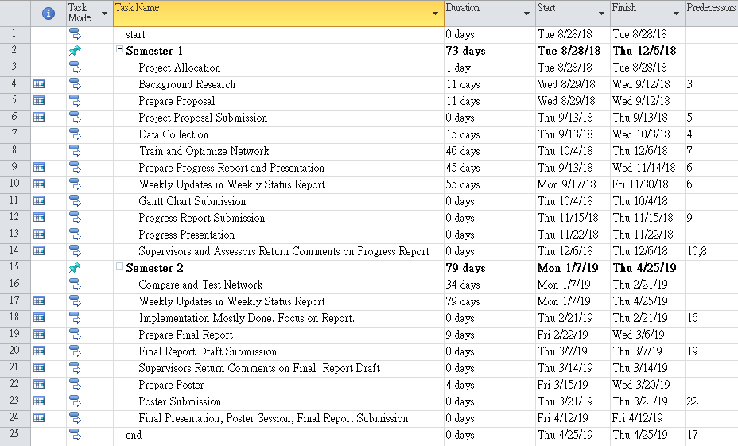Gantt chart

**Figure 77 Gantt chart 1**

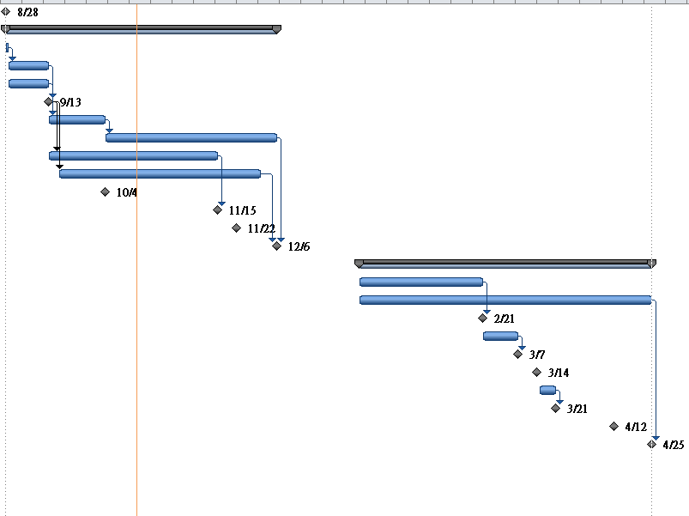

**Figure 78 Gantt chart 2**

Appendix B. Reflection

This project is must be the biggest challenge which I have done. Thankfully, I finish the project on time. No matter how much score I got, I at least try my very best and spend a lot of time on this project. There are several things that I have learned from doing this project.

1. I have overcome the fear of reading papers and learned how to read papers.
2. Before working on the project, I should consider the risks and potential problems holistically.
3. Time management is important. I learn how to set the buffer time more dynamically according to the serious level of unexpected incidents.
4. It would be less stressful that if I set the priority of TODO tasks. Thinking too much only wastes your time and make you anxious.
5. Believe in yourself.